Progress Report for the AMS-02 TRD Gas System

MIT, Cambridge, MA 02139

Figure 1: Overview of the TRD Gas System. Pressures at 25 ºC

During TRD operation the Xe:CO₂ (or CF₄) 80:20 gas is circulated through the TRD detector by pumps in Box C several times per day. The performance is monitored by calibration tubes in Box C. Box S provides 7 liters of fresh gas daily to the TRD.

Box S Contact: U. Becker, R. Henning (MIT)

The flow diagram for the supply box is given below. It transfers a controlled amount of gas from the Xe and CF₄ (CO₂) containers into the daily buffer vessel D.

V1a
V2a
V17a
F2a O1a V3a
V1b V2b
F2b O1b V3b
7 liter/day

to BOX C

3 years
D
V20a
P1a
P1b
Xe
CF₄
T
T
V20b
V4 O2
P3a
T
RV3
300psi
V5
V17b
P3b
T
D
F1a
F1b
RV1b
2800psi
Fill
Ground Equipment
RV1b
2800psi
Fill
Ground Equipment

T temperature sensor
man. valve
relief valve
electro valve
filter
flow restrictor
pressure sensor
end cap

pressures Xe (25⁰C) 1550 psia CF₄(25⁰C) 1740 psia
Vessels: Xe (65⁰C) 3000 psia CF₄(65⁰C) 3200 psia

Figure 2: Schematic for Box S

The gas from the supply vessels is filtered and then metered into manageable quantities trapped in the tubing between solenoid valves. Subsequently the flow is controlled via flow restrictors. Gas from the two supply vessels is mixed in vessel D by adding controlled partial pressures. Relief valves insure that NASA safety regulations are met and that no part of the system is exposed to excessive pressure. Three valves in series and a flow restrictor protect the rest of the TRD gas system from the high pressures of the supply vessels.
MIT is in the final stages of negotiating a contract with Arde Inc, who have extensive experience with ISS and STS projects, for the manufacture of the pressure vessels (Xe: ARDE D4636, CF₄: ARDE D4683, D Mixing Vessel: ARDE SDK 13181) and the construction of the flight version of Box S. A kick-off meeting to discuss contractual and technical details is scheduled for April 27. According to the contract MIT will provide Arde with the components to be used in the assembly and test of Box S. Hence, MIT is currently testing prospective components for Box S.
Initial problems involving the Marotta MV100 high pressure valves have been resolved by using special cleaning procedures for pipes and fittings. An ultrasonic cleaner has been acquired for this purpose. The MV100 valves have been tested in the Building 44 cyclotron magnet and found to remain leak tight up to 8000 Gauss. This exceeds the fringe fields of 300--1500 Gauss at the location of Box S. Studies on the mass flow as a function of time the valve is opened have been performed succesfully. Future studies will include the effect of magnetic fields on valve endurance. A study of the effect of CO₂ freezing in the valve when it adiabatically expands is planned. Prototype driver circuitry for the valves have been built and tested. Schematics have been provided to the Rome group for flight design.
Lee Viscojet flow restrictors (Part Number VDCA183041H) that utilize special geometries with openings 10 times larger than regular flow restrictors, hence reducing clogging problems, have been acquired. These restrictors require the same cleanliness procedures as the Marotta valves. Initial tests show that the restrictors behave as specified. More tests will be conducted upon the arrival of special fittings for the restrictors.
GP-50 Pressure transducer have been ordered and we are awaiting their arrival. We are currently using off-the-shelf Omega components in our prototype system.
A prototype of Box S has been constructed (see Figure 3). It will be used to test flight components and currently has Marotta MV100 valves installed. In the future it will also use GP-50 pressure sensors and Lee Restrictors. It utilizes a Universal Slow Control Module (USCM), based on a successful predecessor in AMS-01, to control gas transfer. The USCM is being built at Aachen III by V. Commichau. Software controlling the gas mixing process and safety is being developed by MIT and K. Hangarter (Aachen-III).
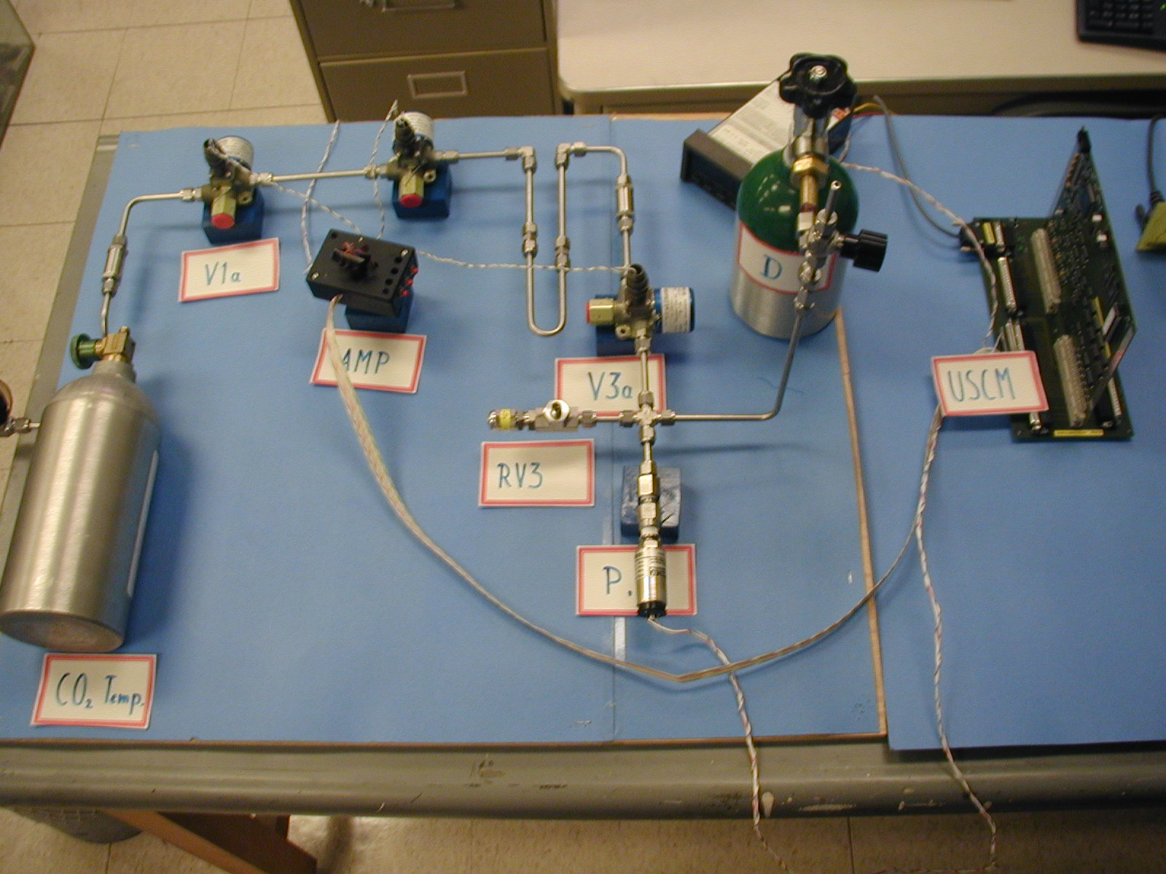
Figure 3: Box S Prototype

The mechanical design and integration of the flight version proceeds in the AMS integration office at CERN in conjunction with Arde Inc. and Lockheed Martin. A first version used in the first safety review in March 15 in Houston is given in Fig. 4.
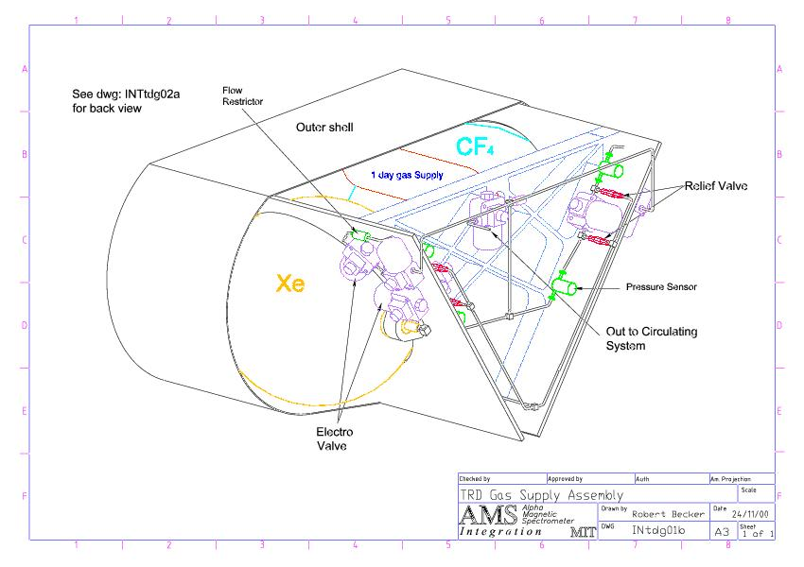
Figure 4: Box S as presented at the Safety Review on March 15, 2001 in Houston.

Box C Contact: P. Fisher, G. Carosi, B. Monreal (MIT)

Analyzer
Circulation pump
from Box S
V6
V8B
V8A
CP1
CP2
Manual valve
Relief valve
P
P3
P4
RV4
P5
RV5
V18
Check port
Purifier
V9
Pressure Sensor
Self-Sealing Connector

To
Manifold

From
Manifold

Electromechanical Valve

Figure 5: Schematic of Box C

The schematic design for Box C has been finalized. Some of the flight hardware has been selected. The flight version contains 1 Marotta MV100 high pressure valve, 3 Buerkert 6123 low pressure flipper valves, 2 relief valves (Stra-Val RVC-05THD), two diaphragm pumps (KNF-Neuberger), a Square One Technology CO₂ analyzer, and 5 temperature and pressure sensors. Mechanical design of the box, in particular of the pump enclosures, has begun, and prototypes have been built.
MIT has constructed two prototypes of Box C to date. One model is undergoing circulation tests with a calibration tube. The other model has been installed at RWTH-Aachen for long-term testing of TRD straw modules under vacuum. A third prototype containing all welded connection and a flight configuration of the pump housing is under construction. The pump has been tested in a magnetic field and will operate in the magnetic field expected. A prototype circuit for pump control and monitors has been designed and built. Schematics of the circuit have been provided to the Rome group.
A Xenon recovery and storage system has being built at MIT. A cryogenic pumping system that is capable of extracting Xenon from the storage vessels and storing it in a removable bottle is under test. Preliminary testing of the pumping capacity indicates the system will be able to store the full Box S Xenon supply. The system also contains a residual gas analyzer for gas composition and contamination checks.

Manifolds Contact: J. Burger (MIT)

From Box C, 6mm stainless steel gas lines run to the top rim of the TRD and to input and output manifolds. These manifolds are developed by MIT at CERN and interface to the TRD being built at Aachen. The 5248 tubes of the TRD are grouped into 41 segments composed of two towers of four 16 tube packages. The packages are connected in series to the manifolds to form 41 separate gas circuits, which can be isolated from the rest of the system by isolation valves on the input and output, as shown in Fig. 6. The valves are doubled for redundancy. There are two (for redundancy) pressure sensors across each of the valves. 1.6mm o.d. CuNi tubing runs from the valves to the segments, where it is joined to PEEK tubing. Carbon fiber tubes around the sides of the TRD, which are attached to the top and bottom honeycomb panels, support the manifolds, the gas tubing and cables.
The isolation valves work in two modes. In case of a sudden pressure drop or power failure, the valves are closed automatically to prevent further gas loss. As a periodic check the valves may be closed and the pressure monitored to detect a slow leak.
The Bürkert type 6123 2/2way flipper valves require a 100ms 12V, 1.5W, pulse to open or close. At other times they consume no power. The valves have been tested to be leak tight to better than 6×10⁻⁷ liter mbar/sec. at 1 bar across the valves. They operate in a magnetic field of 500 Gauss directed perpendicular to the plane of the valves. The valves are positioned at the sides of the TRD in a region where the field is on the order of 100-200 Gauss. They will be enclosed in magnetic shielding boxes in groups of five or six sets of valves. The boxes will also serve as leak protection for the valves. Figure 7 shows a prototype assembly of six valves. An alternative all metal valve is under test .
The assembly shown also contains three Honeywell 24PC series pressure sensors. They operate at 10V, 25mW. Fig 8 shows their output response to pressure in a test to ±1.84 bar. Shut-off limits can be set accurately. The flow resistance of the straw tube packages, valve assemblies and CuNi and stainless steel tubing of various diameters have been determined with an 80:20 Xe:CO₂ gas mixture and pose no problem. Special fittings have been constructed in Aachen to join 1.6 mm metal tubing with PEEK tubing, and we are testing an alternative method with fittings that will be glued in place.
Vibration testing of the valve and pressure sensor assemblies will be done in Aachen.

VNNd
to manifold
TRD Segment NN – 112 cu. in.
from manifold
VNNa
VNNb
VNNc
PNNa
PNNb
Figure 6: One of 41 gas circuits, with isolation valves and pressure sensors on input and output.

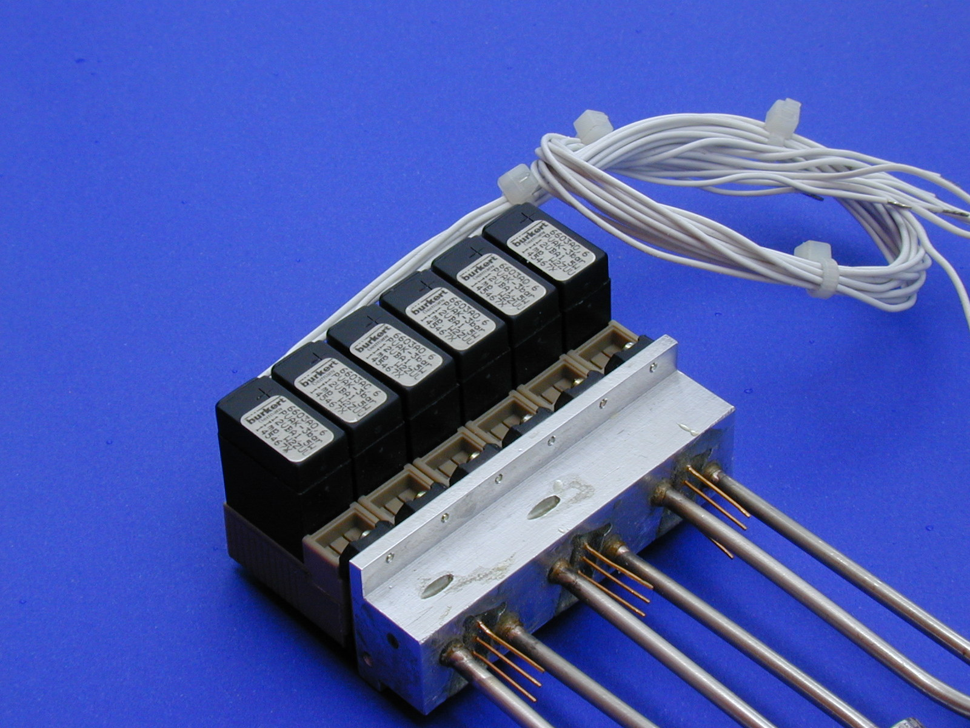

Figure 7: Prototype assembly of six valves with pressure sensors.

Figure 8: Response of a Honeywell pressure sensor during test to 1.84 bar.

MIT has designed prototype flight calibration tube that can be hermetically sealed and fulfills the NASA requirements concerning radiation sources in space. See Fig. 9. One of these tubes is being used by Box C for gain stability tests.

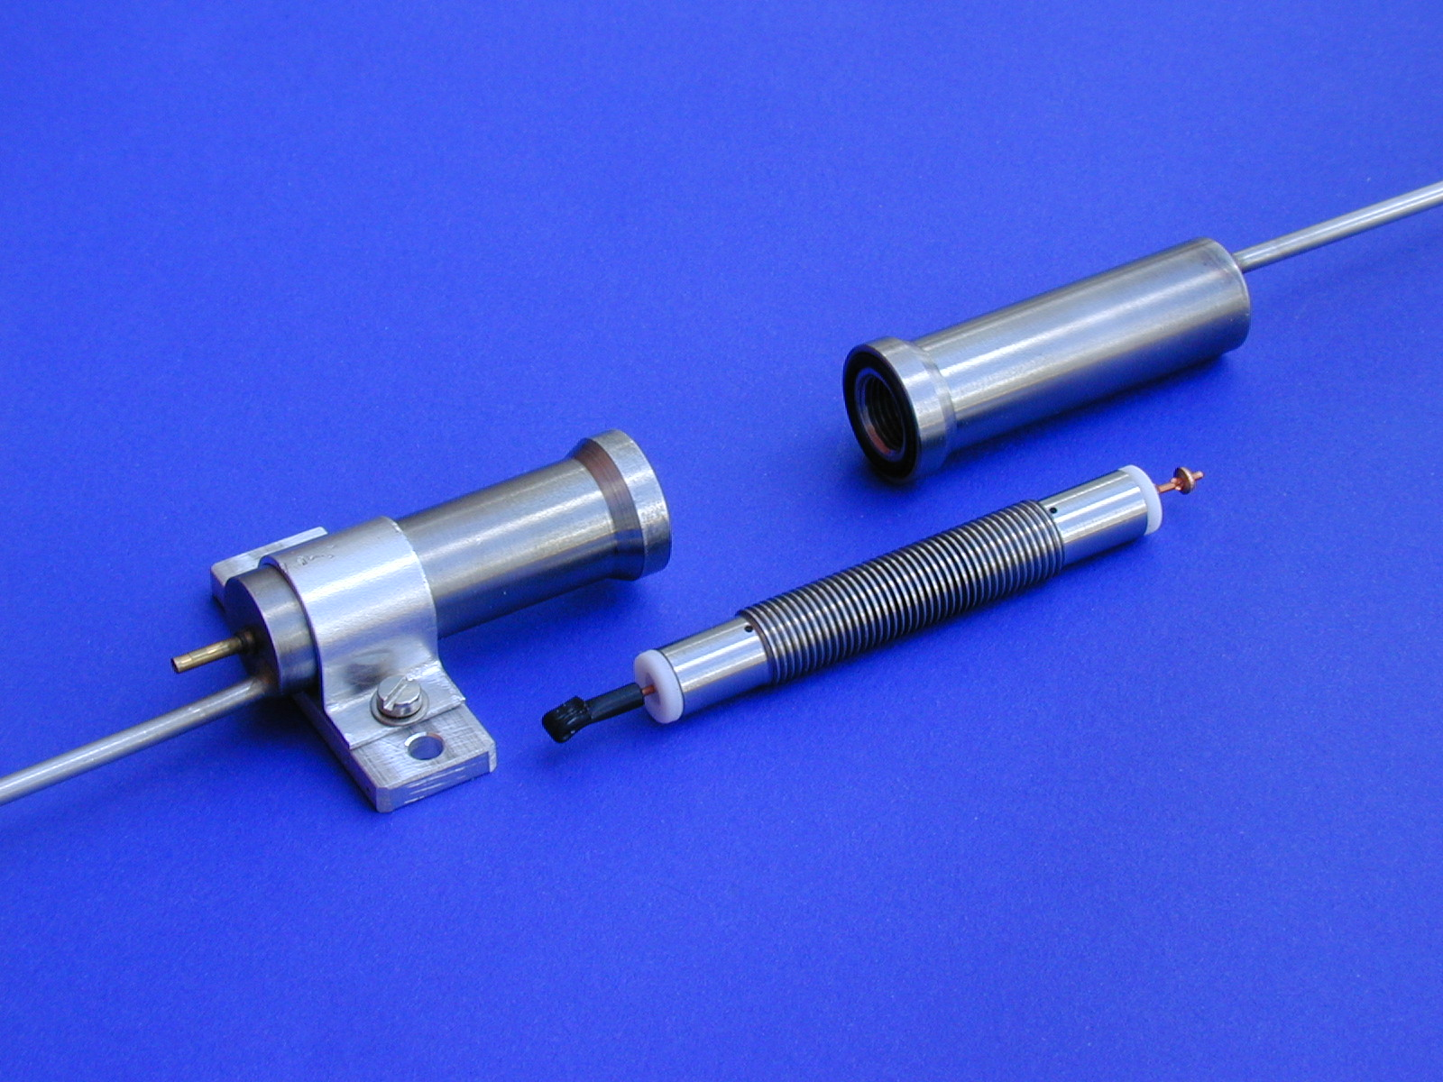
Figure 9: Prototype Flight Calibration Tube.

Electronics Contact: A. Bartolini, B. Borgia, S. Gentile (INFN-Sezione di Roma)

The UGSCsc and UGSCm provide an electronic interface between the USCM (Aachen III) and the flight hardware and will be the responsibility of INFN-Sezione di Roma (pending approval). The USCM uses a sophisticated addressing scheme for digital control at low power that require interface electronics at high power. A schematic for the interface electronics has been developed.
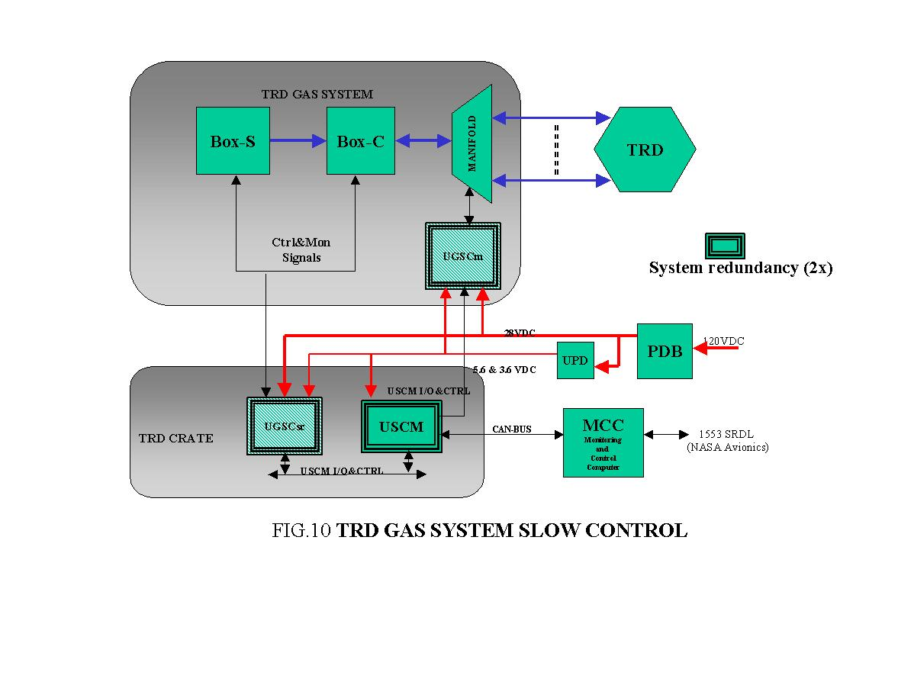
As seen in Figure 10, there are two parts to the TRD Gas System Slow Control (TGSSC) that are represented as hatched boxes:
- UGSCm (Unit Gas System Control Manifold) Controls and monitors the isolation valves, pressure sensors and temperature sensors of the TRD manifolds. It will be situated close to the TRD. It will control the flow of gas through the TRD modules.
- UGSCsc (Unit Gas System Control for boxes S and C) Located in the TRD electronics crate, it will control Box S and Box C operations. It will perform necessary shutdowns in case of power and communications failure to prevent overpressure.

Both units are designed with redundancy and high reliability components. The USCM will transmit control signals and receive transducer data and alarms. Both are powered by a UPD (Unit Power Driver) that provides necessary voltage and current to operate valves, pumps, and the other parts of the TRD system.
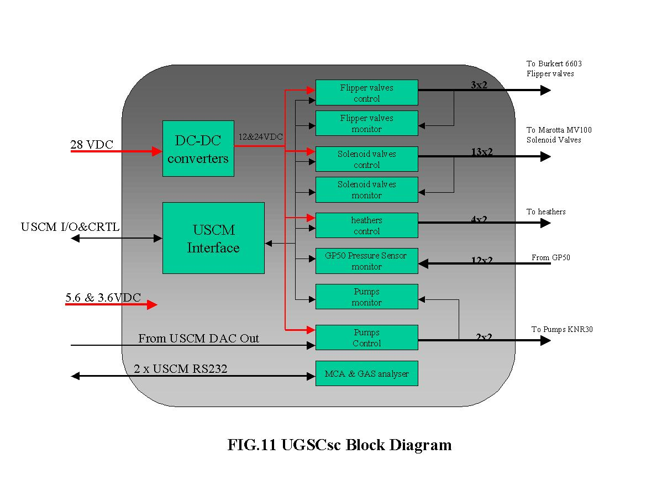
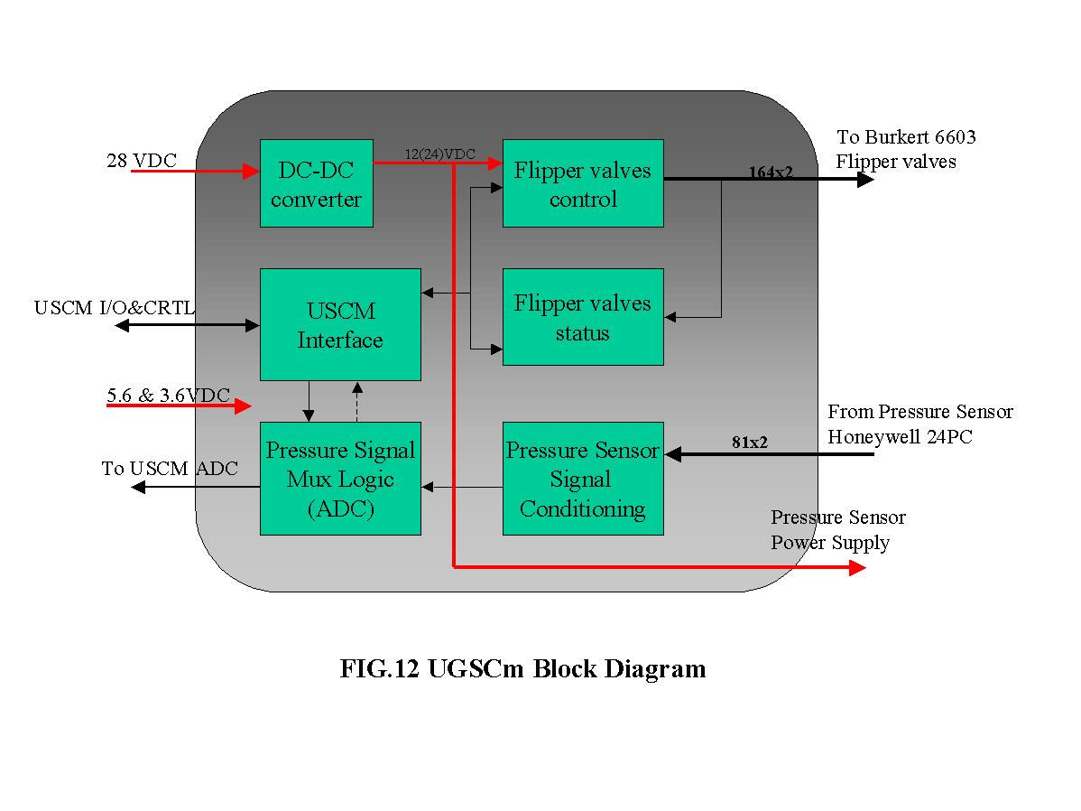
USCM Interface and Control Software Contact: A. Lebedev (MIT)

The USCM periodically reads out all data from all temperature and pressure sensors, the gas analyzer, valve status (open/close), etc. Thus, the USCM knows the complete status of the TRD gas system.
The USCM listens to the CAN-bus to which it is connected. If there is a command on the CAN-bus addressed to this USCM, it is executed and the reply package is sent back to the CAN-bus. The possible commands are "read" or "write". Execution of a "read" command is just copying the relevant portion of already available information to the reply package. Execution of a "write" command is just loading the USCM interface registers and/or DACs with data from this command package, the reply in this case is simply an acknowledgement.
The commands on the CAN-bus are produced by the MCC (Main Control Computer) and/or the MDCs (Main Data Computer). Some ("obvious") commands are pre-stored in the MCC and/or MDCs and are periodically sent via the CAN-bus. Some ("rare" or "exotic") commands from the ground personnel, the Orbiter, or the ISS crews are sent via the 1553 interface, the MCC, the HRDL interface, or the MDC. There will be a general (AMS-wide) data format for these commands.
The USCM includes the monitoring program, which checks the status information about the gas system status against pre-set conditions and executes required commands. The conditions and commands are stored in the format of a decision table.

TRD Calibration in-situ Contact: A. Kounine (MIT)

There are several factors that may affect TRD performance: uniformity of the tube geometry, the spread in the amplification factors of the electronic channels, the uniformity of the magnetic field across the TRD volume, and gas density fluctuations. Some of these factors (gas density variations and amplification coefficients of the electronic channels) are expected to vary during the flight and require in-situ calibration. Studies showed that e-p separation is not compromised if the uniformity of the TRD channels is 5% or better (A. Kounine, V. Koutsenko, AMS note 2000-03-04, 20 March, 2000).
Two TRD calibration methods are under investigation: calibration with protons and random trigger calibrations in SMA. A test setup has been built at CERN to study the performance of both calibration types.
Calibration with protons is based on analyzing the amplitude spectrum of protons recorded by AMS (Figure 13). The shape of the amplitude spectrum in a TRD tube is compared with the reference spectrum to extract an amplification factor corresponding to that tube. Corrections for temperature, track position inside the tube and proton momentum have been applied to extract the intrinsic tube gain factor.
Random trigger calibration in SMA is based on analyzing a spectrum of random signal in the TRD. The flux of charged particles in SMA (most of these particles are protons of few hundreds MeV) is comparable to the flux from a Ru¹⁰⁶ --source used for tests. This procedure does not require dedicated electronics. The gain fitting procedure is conceptually similar to that for calibration with protons.
Both procedures are feasible for use in the ISS, they provide similar precision of gain determination to about 3%. However, the time to achieve such accuracy is about 1 day for the proton calibration and about 10 min. for the random trigger calibration.
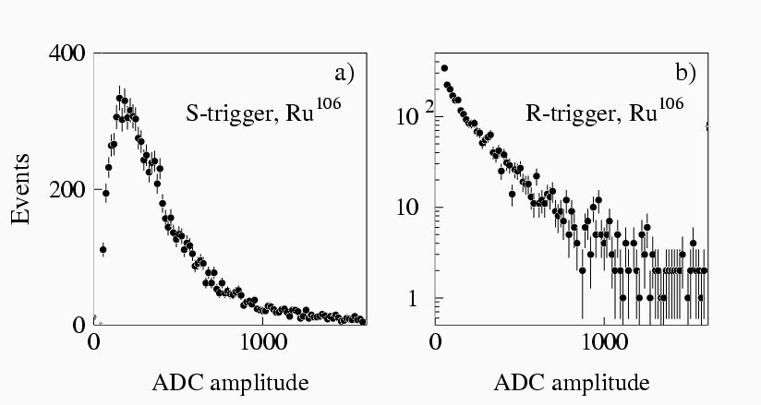

Figure 13: Single tube spectra for self-trigger and random trigger calibration.

