Acceptance Tests Specifications

UG electronics FM Crate
Thermal Stress
and
Thermal-Vacuum Test Procedure
Bruno Borgia - INFN Roma
30 July 2026

Table of Contents

Table of Contents 1
1 Introduction 2
2 FM test configuration 2
Hardware 2
3 Test profile 6
Appendix A – List of material to be put in TV chamber 9
Appendix B – Step by step procedure for TVT test 9
Appendix C – Step by step procedure for ESS test 11
Appendix D – Procedure for vibration test................................................................... 11

1 Introduction
This document describes the test procedure for the space acceptance test of one of the electronics crates of the AMS02 experiment, the crate controller of the gas circuit for the subdetector called TRD (Transition Radiation Detector): the UG crate.
A general description of the AMS02 experiment can be found in the following site: http://ams.cern.ch/AMS .
The UG crate construction and test is responsibility of INFN Roma who made the projects and the tests of the Engineering Models and of the QM2 version. The AMS02 TRD Gas circuit will be equipped with one such crate. The Space Acceptance tests of this crate will be performed on the Flight Model (FM) according to the procedure descibed in this note.

The FM tests of the crate will follow the guidelines specified in http://ams.cern.ch/AMS/electronics/SubD/qa/ where most of the reference documents can be found.

Comments to this document should be addressed to bruno.borgia@roma1.infn.it
Requests for missing data may be addressed to renato.bellarosa@gaengineering.com

2 FM UG test configuration

Hardware
All the material going inside the TV chamber has to fulfill specific criteria and must be declared before entering the facility. Appendix A lists all the components which will enter the chamber. This list must be approved by the engineers running the facility.
The main component is clearly the UG and the UGPD crate, supplying the power by DC-DC converters, while all the other hardware needed to test the UG crate functionality, power supplies computers etc., will reside outside the vacuum chamber.

The UG Crate
The crate has been built by G&A Engineering, following the drawings provided by Carlo Gavazzi Space (CGS) .
Fig.1 shows a picture of the mechanics. The material used for the construction is specified by the CGS drawings.

The boards
The crate is equipped with a total of 8 boards of 4 different kinds, plus a backplane to which the boards are connected. The boards are:
- 2 UGSCM
- 2 UGBS
- 2 UGBC
- 2 UGFV

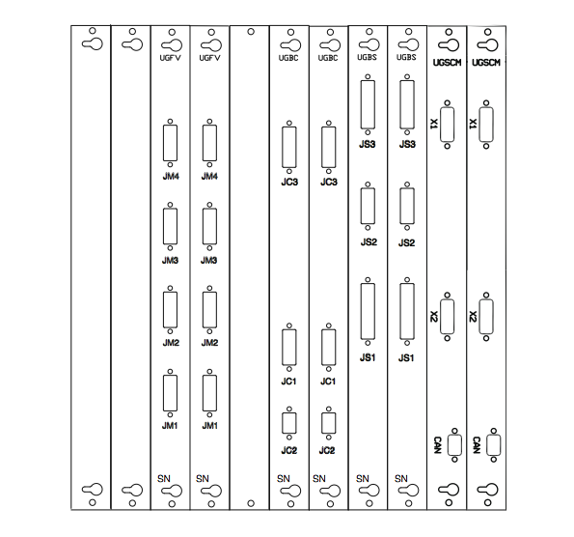
Figure 1 – UG modules front panels

Except for the UGSCM, which is provided by the AMS electronics team, all the other boards have been projected, engineered and tested by INFN Roma.
For the Space Acceptance tests, 2 FM boards per type was built. We must test and qualify the functionality of hot and cold modules simultaneously present on the system.
Spare modules will be tested at later time.

The UGPD Crate
The UGPD crate was built by CSIST Taiwan and will be avalaible only for the TVT test. The 28V power supply needed by the UGPD crate will be supplied by an external power supply using an existing power line previously employed for the 29V.
The ESS test will be performed in the same configuration as the Qualification test of the UG QM2 crate, i.e. with all necessary power supplies external to the thermal chamber.

Ancillary hardware
The acceptance test must be performed while testing full functionality of the UG crate. For this reason, a Test Station (UGTS) with a set of 6 boards simulating the input/output operations of TRD gas circuit are connected to the UG crate. The connection scheme is sketched in fig.2 for the ESS test. The TVT test will have the UGPD and the UG inside the TV chamber


POWER SUPPLIES
TEST
GAS SIMULATOR
ADC/DAC
NATIONAL INSTRUMENT
TEST STATION
UG CRATE
THERMAL CHAMBER
CHAMBER
CAN
BUS

Figure 2 - Schematics of UG crate test connections

The connection between UG crate and the test station UGTS is done through thermal-vacuum flanges (DNC200) equipped with TV qualified feedthroughs DB 37 pin connectors (ITT CANNON socket housing D37 way cod. DCA37S-A197-F0 + ITT CANNON crimp socket cod. 3307636010). The cables inside the chamber are RAYCHEM cod. 44A0111-20-9.

3 Test profile
Following the directions reported in the document http://ams.cern.ch/AMS/electronics/SubD/qa/,
the test will be performed in two steps:
- ESS (Environmental Stress Screening): a test in air with STARTUP+10 CYCLES+ VIBRATION+STARTUP+ 5 CYCLES +END
- TVT (TermoVacuum Test): a test in vacuum with STARTUP+4 CYCLES +END ,
where the meaning of STARTUP, CYCLE, END are described in fig. 3 and 5.

The test temperature profiles are sketched in fig.3 and 5 with the following definition of temperature levels:
- T_{AMB} = ambient temperature
- T_{NO-max} = hot storage, non-operating temperature = +80 ºC
- T_{NO-min} = cold storage non-operating temperature = -40 ºC
- T_{Q-max} = hot operating temperature = +50 ºC
- T_{Q-min} = cold operating temperature = -20 ºC
The pressure must be below 10⁻⁴ hPa to set the first hot storage temperature, and below 10⁻⁵ hPa before the first switch on operation.

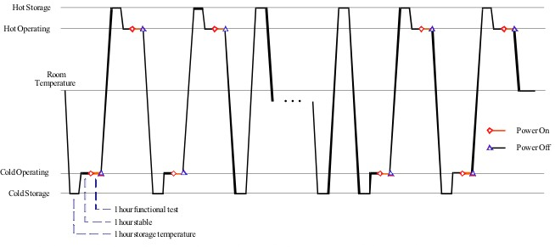

Fig. 3: ESS Temperature profile

The stabilization time is defined by the following condition:
- the condition |ΔT|/Δt<1^{O}/hour is reached and mantained for at least 1 hour; that is the temperature remains stable and within 1^{O} from the setting for at least 1 hour.

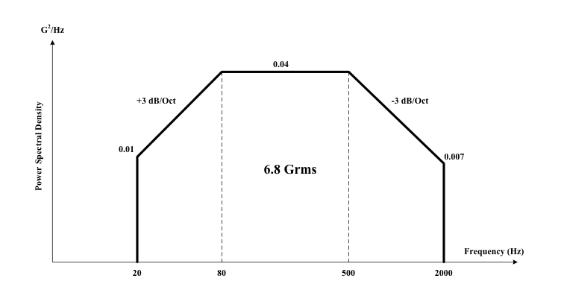

Duration of vibration test: 1 minute for each axis.

Figure 4 - EES Vibration profile.
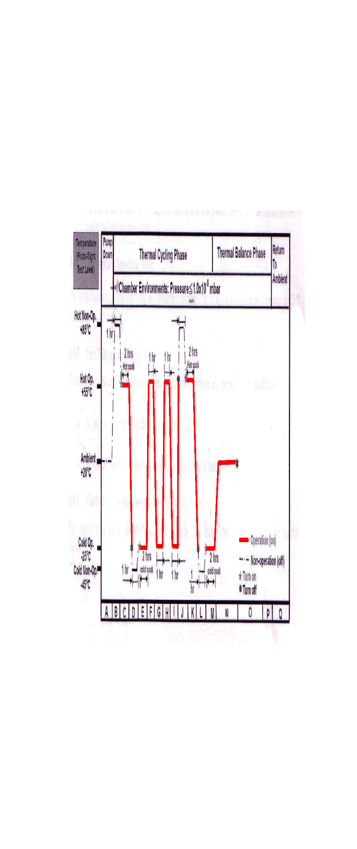
Fig. 5: TVT temperature profile

TRP location
All the temperatures described in this document are referred to the Temperature Reference Point (TRP). One TRP will be located on the UG crate and a second TRP will be located on the UGPD crate. The location of the TRPs is shown in the following picture:

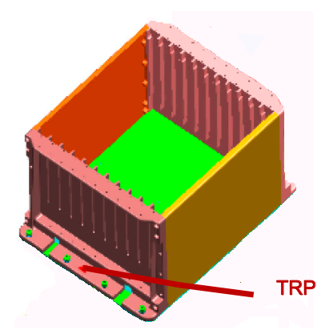

Appendix A – List of material to be put in TV chamber

ITEM | Origin | Provider | Mass (kg)
UG crate | G&A Engineering | INFN-Roma | 5
Baseplate for TVT | G&A Engineering | G&A Engineering | 3
Baseplate for ESS | INFN Roma | INFN Roma | 3
Connectors + Wires | Glenair | G&A Engineering | 2
Wires |  | G&A Engineering
Connectors DB 37 pin |  | G&A Engineering | 0.5
UGPD crate | CSIST | CSIST | 4
Baseplate for TVT test of the UGPD | SERMS | SERMS | 3

Appendix B – Step by step procedure for TVT test

- TEST ARTICLE SETUP
  - PT100 thermal sensors are fixed to the external surface of UG crate.
  - UG and UGPD crate is fixed on the baseplate.
  - Aluminum baseplate is fixed on the chamber cold plate.
  - Low voltage power supplies and ancillary electronics (gas system simulator.......) are put on a table outside the TV chamber.
  - Cables are pulled between UG crate and flanges with feedthroughs and between flanges and external electronics.

- PRELIMINARY TEST
- The electronics is switched on and a functionality test is performed. Communication is via EPPCAN bus. The operation sequence, together with temperatures, pressures, status flags that are read out during the test, are stored in a pc together with the output from the Test Station.
    - UGSCM A and B are initialized;
    - all valves controlled by UGBS (V1a, V2a, V3a, V4a, V10a, V20a, V1b, V2b, V3b, V4b, V10b, V20b, Sp1, Sp2) are enabled and opened for 5 s one at a time, and status is read, then disabled;
    - all pressure sensors controlled by UGBS (P1a, P2a, P1b, P2b, Pk1c, Pk2c, Pk1d) are read out;
    - all heaters controlled by UGBS (H1, H2, H3, H4, H5) are enabled and started for 1 minute, then disabled, one at a time;
    - operations ii to iv are repeated 4 times: [UGSCM-A + UGBS-A], [UGSCM-A + UGBS-B], [UGSCM-B + UGBS-A], [UGSCM-B + UGBS-B];
    - all power supplies (29V, 12V, 5V, 8.5V) controlled by UGBC are enabled, and the status is read out;
    - all valves controlled by UGBC (V6a, V18a, V6b, V18b, V6a&V18a, V6b&V18b) are enabled and opened for 5 s one at a time, and status is read, then disabled;
    - all pressure sensors controlled by UGBC (P3, P4) are read out;
    - all circulation pumps controlled by UGBC (CP1, CP2) are enabled at H speed, started and stopped after 5 s, then enabled at F speed, started and stopped after 5 s then disabled, one at a time;
    - all UGBC serial ports (RS232_1, RS232_2, RS232_3, RS232_4) are enabled and the status is read, then disabled;
    - all power supplies (29V, 12V, 5V, 8.5V) controlled by UGBC are disabled;
    - operations vi to xi are repeated 4 times: [UGSCM-A + UGBC-A], [UGSCM-A + UGBC-B], [UGSCM-B + UGBC-A], [UGSCM-B + UGBC-B];
    - all power supplies controlled by UGFV (12VPS, 12VFV, 21V, MUX) are enabled;
    - modules 1 to 4 are selected one at a time, and for each module, valves V1 to V5 are opened then closed after 5 s;
    - multiplexers 1 to 4 are selected one at a time, and for each multiplexer all pressure sensors (P1, P2, P3, P4, P5) are read out;
    - all power supplies controlled by UGFV (12VPS, 12VFV, 21V, MUX) are disabled;
    - operations xiii to xvi are repeated 4 times: [UGSCM-A + UGFV-A], [UGSCM-A + UGFV-B], [UGSCM-B + UGFV-A], [UGSCM-B + UGFV-B].
- The time needed to perform these tests is of the order of 15 minutes.

NB: These operations are repeated each time a functionality test is required.

- STARTUP OPERATIONS
  - The chamber is closed and the pressure is set to 10⁻⁵hPa
  - As soon as the pressure reaches 10⁻⁴hPa, the temperature is set to T_{NO_max}=+80^{O}
  - The temperature is reached once the stabilization condition (|ΔT|/Δt<1^{O}/hour) is reached and mantained for 1 hour; this condition must be fulfilled every time in order to define a given temperature as “reached”
  - After the stabilization time of 1 hour, the chamber temperature is set to the value T_{Q-max}=+50 ^{O}
  - Once the temperature at the TRP is T_{Q-max}=+50 ^{O} and the pressure reaches 10⁻⁵hPa , the electronics is switched on
  - After the stabilization time, functionality tests are performed
  - The UG crate is switched off and the chamber set to T_{NO-min}=-40^{O}
  - After the stabilization time, set temperature to T_{Q-min}=-20 ^{O}
  - Once the temperature at the TRP is T_{Q-min}=-20 ^{O} and the pressure reaches 10⁻⁵hPa , the electronics is switched on
  - wait for the stabilization time and perform tests
- CYCLES – to be performed with the device switched on
  - The temperature is set to T_{Q-max}=+50 ^{O}
  - After stabilization, functionality tests are performed
  - The temperature is set to T_{Q-min}=-20 ^{O}
  - After stabilization, functionality tests are performed
- END OPERATIONS
  - The chamber is set to ambient temperature
  - Once ambient temperature is reached, the device is switched off

Appendix C – Step by step procedure for ESS test
The tests in air follows the same procedure described in the previous section, except that the vacuum conditions are obviously not required and that the CYCLES section (point 4.) is repeated for N=10 times before the vibration test and 5 times after.
The functionality test is performed only on the first 2 initial cycles and on the last 2 final cycles.

Appendix D – Procedure for vibration test
The UG crate will be mounted on its baseplate. Then the baseplate will be fixed to the shaker table and vibrated with profile of Fig.4 along x and y axes. Subsequently the shaker drum will be rotated with its axis along the vertical direction and the UG baseplate will be fixed directly on the drum plate for the z axis vibration.
At the end of each cycle, we will perform the full functionality test.

