TEST REPORT
VIBRATION TEST

input.doc
date: September 11th, 2008
Prot.: 004-09/SERMS

 |  |  |  |  | signature
test report prepared by: |  | 11/09/08 |  | Ing. Stefano Lucidi | 
 |  | Data |  | QA manager
 |  |  |  | 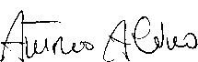
test report controlled by: |  | 11/09/08 |  | Ing. A. Alvino
 |  | Data |  | Test Responsible
 |  |  |  | 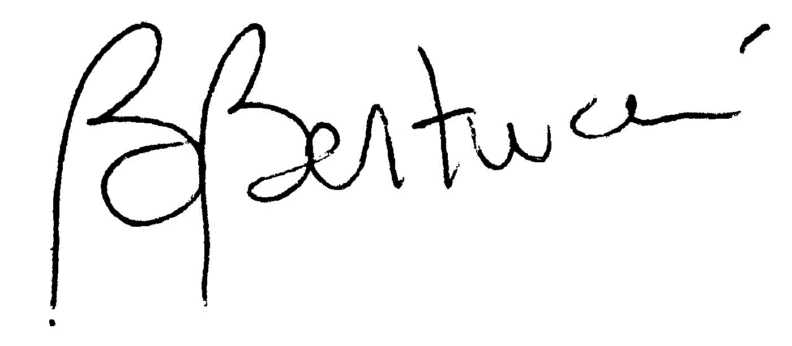
approved by: |  | 11/09/08 |  | Prof.ssa Bruna Bertucci
 |  | Data |  | Lab. Responsible

change record
date | change description | revision
11/09/08 | first issue | 1

NOTICE


REPRODUCTION OF THIS REPORT
Reproduction or duplication of any portion of this report is expressively forbidden, except by those contractors receiving it directly from authorized data interchange offices or the originator, for their internal use or the use of they subcontractors. Reproduction or display of all or any portion of this material for any sales, advertising or publicity purposes is prohibited.


TEST REPORT DESCRIPTION
This document is generated by the S.E.R.M.S. Laboratory and reports on the setup, the operation and the results of the test performed on the customer Device Under Test (D.U.T.); several sections compose this report: all of them have been integrated and adapted to the specific tests performed on the D.U.T.

CONTENTS
GENERAL INFORMATION 4
APPLICABLE LAWS AND RULES 4
SERMS FACILITY - QUALITY ASSURANCE INFORMATION 5
TEST LEVEL SUMMMARY 6
TEST DIARY 7
TEST RESULTS 8
REMARKS 8
Z-AXIS 11
Sub-test description 11
Y-AXIS 10
Sub-test description 10
X-AXIS 9
sub-test description 9
SUB-TEST GRAPHS 12
Z-AXIS 15
Y-AXIS 14
X-AXIS 13

GENERAL INFORMATION

Job Number: S3021R
Universal test number: VIBTEST61
Test performed on: UG CRATE Fs (flight spare module)

contractor: INFN ROMA
contractor responsible: PROF. BRUNO BORGIA
subcontractor: none
test engineer: ANTONIO ALVINO
quality assurance: STEFANO LUCIDI

APPLICABLE LAWS AND RULES

UGcrate_QM2tests-v12 (13/02/08)

S.E.R.M.S Lab. - INTERNAL TEST PROCEDURE

D.L. 19 settembre 1994, n.626
Attuazione delle direttive 89/391/CEE, 89/654/CEE, 89/655/CEE, 89/656/CEE, 90/269/CEE, 90/270/CEE, 90/394/CEE e 90/679/CEE riguardanti il miglioramento della sicurezza e della salute dei lavoratori sul luogo di lavoro, e successive modifiche;
MIL-HDBK-831 23 April 1999
Preparation of Test Reports (guidance only);

UNI –10653 – November 1997
Quality product technical documentation (guidance only) ;

UNI CEI EN45001
general criterion for test laboratory operation;

UNI CEI 70001
norm certificate test laboratory terms and definitions;

UNI CEI 70011
guide for test result presentation;

UNI 9513
vibration and shocks : vocabulary.

SERMS FACILITY - QUALITY ASSURANCE INFORMATION

CALIBRATION DUE DATE
item | manufacturer | due date
Control System | Spectral Dynamics | 04/04/2009
Shaker | Ling Electronics | maintenance
Slip Tables | Team Corporation | maintenace
Sensor | Metra-Mess | july 29 2009
  CH | ModelAcc | SERIAL | SENSE mV/g
  7 | KS 95-100 | 4054 | 101,44

TEST LEVEL SUMMMARY
The subtests performed are:

TEST DIARY

test begun: September 4th, 2008
test completed: September 4th, 2008

The following table shown the subtests performed for the UG-CRATE equipment:

Vibration test UG CRATE - FLIGTH - 4 SETTEMBRE 2008 - PIASTRA SCURA
NOME FILE | DATA | INIZIO | FINE | CHANNELS | NOTE
UGF_X | September 4th, 2008 | 9.00 |  | CTRL - CH 7; | test successfully completed
UGF_Y | September 4th, 2008 | 9.47 |  | CTRL - CH 7; | test successfully completed
UGF_Z | September 4th, 2008 | 14.00 |  | CTRL - CH 7; ctrl ch49 | test successfully completed

TEST RESULTS

The device under test has been tested with random vibration along its three orthogonal axes in September 2008 at S.E.R.M.S. Lab. in Terni.

The planned tests have been executed according to the test procedure and the required input
levels have been verified.

Visual inspections of the D.U.T. have been performed after each sub-test.

IN ALL PERFORMED SUB-TESTS (SINGLE AXIS) NO DAMAGE HAS BEEN REPORTED.
ALL SUB-TESTS HAVE BEEN NORMALLY COMPLETED.

The complete set of test data recorded will be provided on customer request; in this report only the most significant test data will be summarized.

REMARKS
All the functional test on the equipment are reported on the following customer document:

UG Crate FM acceptance test, AMS Roma 02/08 (5/5/2008)

R1.
none

X-AXIS

Details on the performed sub-tests are shown in this section. Note that for each sub-test all the information on the collected data will be reported in “SUB-TEST PARAMETERS AND SUB-TEST GRAPHS” section of this document.

sub-test description

The general view of the test setup for the X-axis is shown in figure 1. For the X-axis sub-test the DUT has been mounted over the fixture matching the X-axis of the DUT with the slip table axis, as shown below. Many sensors (channels or CH) have been used during this sub-test. They were fixed on the DUT by cyanoacrilic glue.

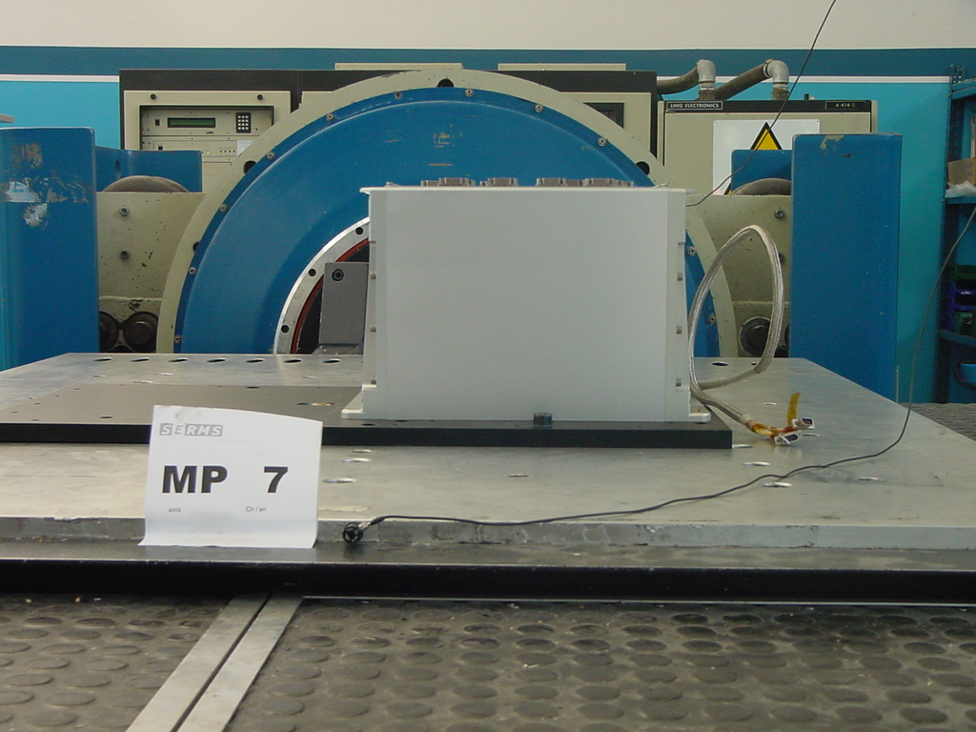
FIGURE 1: X-axis test set-up.

Y-AXIS

Details on the performed sub-tests are shown in this section. Note that for each sub-test all the information on the collected data will be reported in “SUB-TEST PARAMETERS AND SUB-TEST GRAPHS” section of this document.

Sub-test description

The general view of the test setup for the Y-axis is shown in figure 2. For the Y-axis sub-test the DUT has been mounted on a fixture matching the Y-axis of the DUT with the slip table axis, as shown below. Many sensors (channels or CH) have been used during this sub-test. They were fixed on the DUT by cyanoacrilic glue.

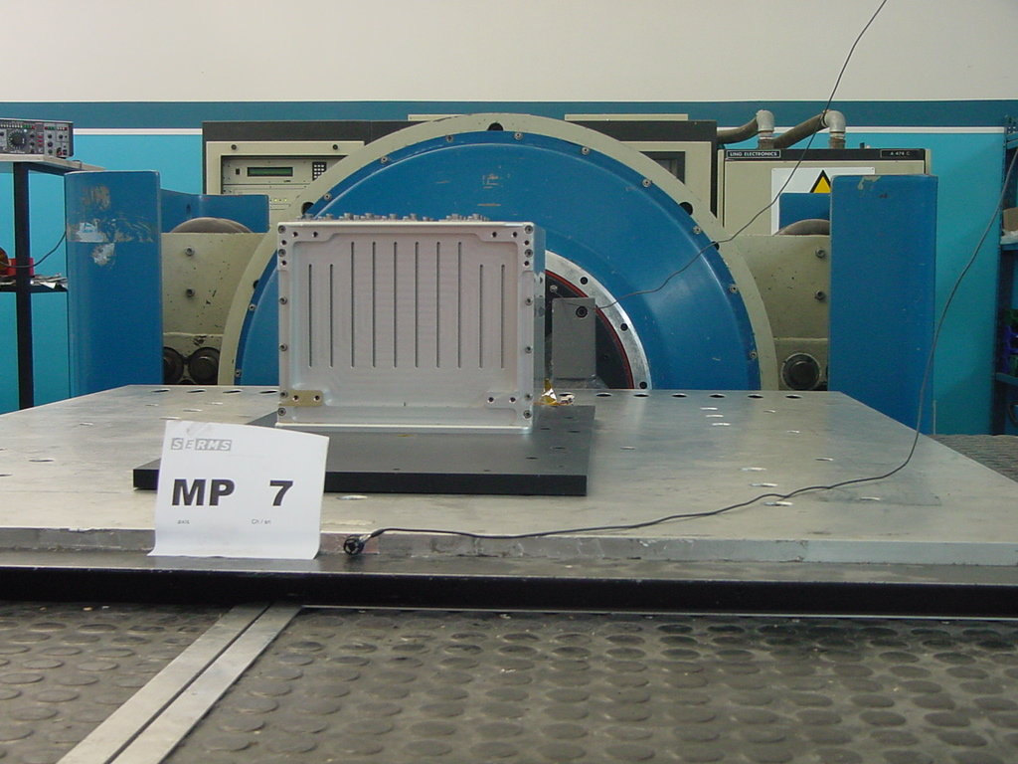
FIGURE 2: Y-Axis: test set-up.

Z-AXIS

Details on the performed sub-tests are shown in this section. Note that for each sub-test all the information on the collected data will be reported in “SUB-TEST PARAMETERS AND SUB-TEST GRAPHS” section of this document.

Sub-test description

The general view of the test setup for the Z-axis is shown in figure 3. For the Z-axis sub-test the DUT has been mounted on a fixture matching the Z-axis of the DUT with the slip table axis, as shown below. Many sensors (channels or CH) have been used during this sub-test. They were fixed on the DUT by cyanoacrilic glue.

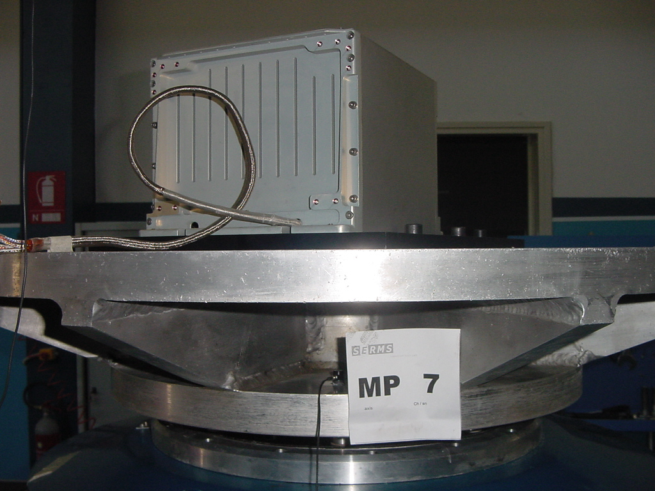
FIGURE 3: Z-Axis test set-up.

SUB-TEST GRAPHS

The S.E.R.M.S. Lab. guarantees that the test set-up and management is done only by authorized and qualified members of the S.E.R.M.S staff according to the customer specifications.
After the input of the test engineer, the control system records the parameters for all the different sub-tests and automatically generates the corresponding printable output files.
The graphs are automatically generated during the test by the control system and directly inserted into this report;

X-AXIS

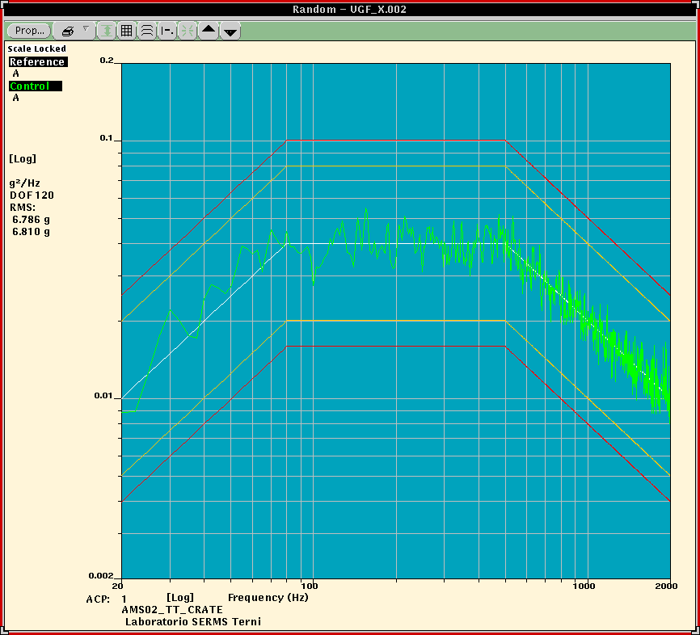

FIGURE 4: X-AXIS random.

Y-AXIS

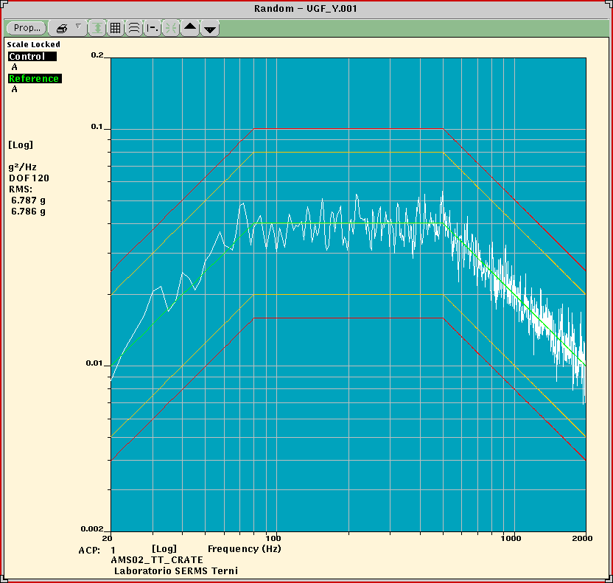
FIGURE 5: Y-AXIS random.

Z-AXIS

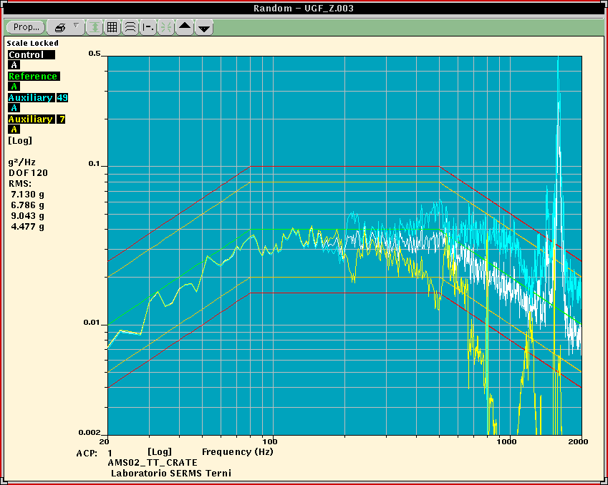

FIGURE 6: Z-AXIS random.

