Transition Radiation Detector
Gas Slow Control System
AMS-02
18/12/2001
A. Bartoloni, B. Borgia, S. Gentile
Roma INFN Sezione di Roma
U. Becker, J. Burger, M. Capell, P. Fisher, R. Henning, B. Monreal
M.I.T.

Introduction

The Alpha Magnetic Spectrometer (AMS02) is an experiment on the International Space Station (ISS) intended to measure primary cosmic ray spectra in space. To reach its physics goals a Transition Radiation Detector (TRD) was designed to identify positrons with rejection factor of 10² – 10³ against protons from 1.5 GeV to 300 GeV. The gas control system of the TRD is an essential item for its performance. To obtain the required discriminating power, a stringent control of gas parameters is necessary. For example, a 3°C change of temperature causes 1% gas density variation, which corresponds approximately to 5% gain variation.
Therefore the design of the control system must obey to tight requirements of safety and reliability.
The general layout of the control system is shown in Fig.1.1
During its operation the TRD will use a mixture of Xe/CO₂ gas circulated through a manifold system, a circulation Box (Box-C) and refilled by a supply Box (Box-S). These three blocks constitute the TRD GAS system .
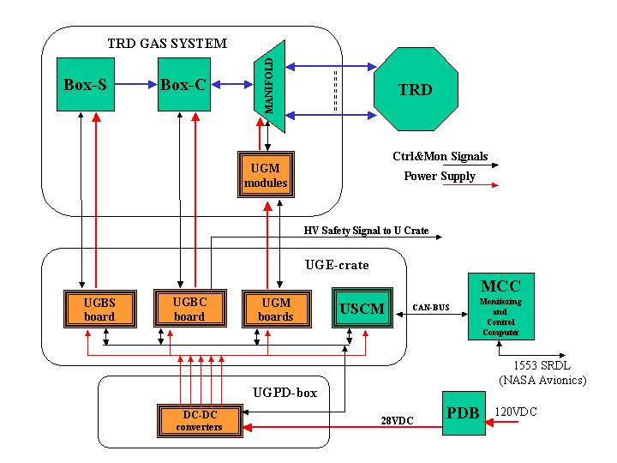
Fig. 1.1 TRD gas system command and control architecture (see text). The black lines indicate the control and monitor signal, the red ones the power supply.
This system includes a Monitoring and Control Computer (MCC) and a Power Distribution Box (PDB), which provides 28 VDC power supply from the 120 VDC, supplied from the Space Station.

USCM (Universal Slow Control Module) The USCM is connected to the Monitor and Control Computer and main data acquisition via CAN-BUS and to the gas system control electronics via a dedicated custom bus (USCM I/O and CTRL in Fig.1). The USCM contains the monitor program, which tests the status information of the gas system against pre-conditions and executes commands. The conditions and commands are stored in form of decision tables.
Its duties are:
- execute the software of control system;
- control and command the sensor and pump interface;
- integrate through a serial bus (CAN-BUS), the TRD gas system in the AMS general command and control system and the more general of the Space Station.

The circuit boards UGBS, UGBC and UGM provide an electronic interface between USCM and electromechanical gas system devices. Their functions are:

UGBS (TRD Gas Control Board for Box-S): located in the UG Crate (TRD Gas Crate) near the Box-S, it will control its operations i.e. providing the correct gas mixture to refill the TRD, monitor the pressure and filling status. It will shut the gas system down safely in case of power and communications failure. In case of overpressure a relief valve will be opened. Monitor and filling status
UGBC (TRD Gas Control Board for Box-C): located in the UG Crate near the Box-C, it will control its operations, i.e. running the pump, opening valves to refill the TRD and monitor gas pressure. It will shut the gas system down safely in case of power and communications failure and generates High Voltage system shutdown. In case of overpressure a relief valve will be opened.
UGM (TRD Gas Control System for Manifolds): controls and monitors the isolation valves pressure sensors and temperature sensors of TRD manifolds. It will be situated close the TRD. It will control the flow of gas through the TRD modules and isolate any leaking segments.
This element is divided in two sections:
- UGPS modules: this board sits close to the detector near the sensors and contains the circuits to adapt the output signals of pressure sensors as USCM inputs. This electronics has to operate in an external magnetic field B ≅ 200 Gauss directed along the axis of the manifold.
- UGM boards: these boards sit in the UG Crate. With this name are grouped two different types:
- UGMUX to multiplex the adapted sensor signals (from UGPS modules) to the USCM input,
- UGFV to control the manifold flipper valves.

UGE Crate (TRD Gas Control Crate): In this crate are located all electronic boards previously described with exception of UGPS modules. This crate uses also a TRD Gas Control Backplane board (UGCB) to distribute the power supplies and USCM custom bus signals to all UG boards. The crate and UG boards (with the exception of the UGPS modules) characteristics follow the AMS standard (§3).
UGPD Box (Gas Power Distribution Box): In this box are located all the filter and control electronics, DC-DC converters included, necessary to provide voltage and current to operate valves, pumps and other parts of the TRD system and the command electronics from the 28V power, supplied from Space Station. Converters are needed for 120, 24, 12, 5.0, 3.3 VDC.

All control and monitor electronics (except UGPS modules, already specified) have to operate in an external magnetic field B approximately of 160 to 200 Gauss.

All boards previously described will be designed using redundancy criteria to cope with failure of one element at the time. No provision is made for two or more failures on the same board. To implement this feature, for every board in operation, hot board, a standby unit, cold board, will be provided. The UGPS modules, sitting on the manifolds, will not have a cold unit, since doubling pressure sensors and valves in the manifold already provides redundancy.
Hot and cold boards can be controlled by either the USCM’s.
The AMS Rome group has the responsibility to design, build and space qualify the electronic boards previously described namely DC-DC converters, UGBS, UGBC, UGPS modules, UGM boards.

TRD GAS System

Box-S
Mix
Box-C
Xe
TRD
CO₂
High pressure:
Xe: 1550 psia
CO₂: 940 psia
Low pressure:
200 psia
17.6-20.4 psia

Fig.2.1 Overview of TRD gas system. All pressures are given at 25 °C

A schematic view of the TRD gas system is shown in Fig. 2.1. The system is divided in three blocks: Box-S, the supply box, where the gas container and the mixer system are located, Box-C, containing controls, circulation pumps, gas analyzer and calibration tubes, and the manifolds that distribute gas to the TRD tubes. The manifolds are equipped with shut-off valves, which can isolate any of the 41 TRD segments in case of leak.
During TRD operation the Xe-CO₂ gas mixture in the ratio 80:20 is prepared in Box-S and transferred to Box-C from a limited transfer volume, vessel D (approx. 1 liter). A feed control between Boxes S and C is activated by computer approximately once a day to accomplish the operations described above. Pumps in Box-C circulated gas at a pressure of approximately of 17.4 psia and temperature of 25 °C. Calibration tubes in Box-C monitor detector performance. The gas contained in the supplies guarantees three years of working operations. These three blocks with their sensors and electromechanical components are shown in Fig.2.2, Fig. 2.3, and Fig 2.4. In the next sections a short discussion of the main functions is reported, referring to elsewhere for a more complete description of TRD GAS system ²

Box-S

The flow diagram for supply Box-S is given below. It transfers a controlled amount of gas from Xe and CO₂ containers into a mixing vessel D. In this way 7-l/day of the fresh gas mixture may be provided to the TRD system.

T temperature sensor
man. valve
relief valve
electro valve
filter
flow restrictor
pressure sensor
end cap
VG1b FG1b
CO2
RV1b
1200psi
Ground Equipment
RV1a
2800psi
Fill Xe
VG1a FG1a
Vent
7 liter/day

to Box-C

3 years
V20a
V20b
V4 O2
RV3
300psi
V5
P1a
Xe
T
F1a
D
D
P1b
CO₂
T
V’1a
V1a
V17a
F3a
P3a
T
V2a
F2a O1a V3a
V1b
F3b
V17b
P3b
T
V2b
F2b O1b V3b
V’1b
15ccm 30ccm
30ccm 60ccm
V’4 O’2
F2b

Fig.2.2 Schematic for Box-S (see text for symbols)

The gas from supply vessels, marked Xe and CO₂ supply, is filtered (F1a, F1b, F2a, F2b) and metered into known volumes between Marotta valves V1a, V’1a, V2a, V20a or V1b, V1’b, V20b and between V2a and V3a or V2b and V3b. Subsequently the flow is controlled via flow restrictors (O1a, O1b). Gas from the two supply vessels is added to vessel D using V3a and V3b. The mixture is controlled by measuring partial pressures P3a or P3b. Mechanical relief valve RV3 (automatically opened when the pressure is higher than 300 psig) insures NASA safety regulations are met and that no part of system is exposed to excessive pressure. Electrical control will be provided on the UGBS board using the valve V5. V5 will be operated to open at pressure higher than 290 psig. Three valves in series (V1a, V2a, V3a or V1b, V2b, V3b) and flow restrictor (O1a or O1b) protect the mixing vessel from the high pressure of the supply vessels. V4, orifice O2 and valve V6a (in Box-C) meter the gas from the mixing vessel into Box-C and protect the rest of the gas system from the high pressures of Box-S. This system is doubled (V’4, O’2, V6b) for redundancy.
The Digital Interface Module (DIM) for the pressure sensors are thermically coupled to the CO₂ flow restrictors. (Xe critical T = 16.6° at P= 58.4 bar, CO₂ critical T = 31° C at P= 73.8 bar).

Box-S operation

Filling Ground State
Vessels cleaned. Connected Xenon ground supply to filling port of Box-S at V17a. Close V1a and V2a and evacuate the fill lines and pressure vessel. Transfer liquid Xenon into container, weight = 109 lb. Close V17a. Record temperature and pressure for 4 hours. If performance is as desired, cap V17a port.
Repeat process for CO₂ line. Filling ports will have different threads so that the wrong thank is not filled by accident.

Before Launch and During Power Off
All valves are closed. Mixing Vessel D will be at 1.2 bar (= 17.4 psi), as will the TRD straw tubes. Pressure and temperature monitoring from the ground should continue uninterrupted for as long as possible prior to launch, during flight to the ISS and mounting on the ISS.

Normal Operation
Mixing
Once per day: For the CO₂ line: Open V1b (approx. 100ms) to fill the buffer V1b and V2b. Open V2b (approx. 100ms) to fill buffer volume between V2b and V3b. The filling of one buffer volume from another buffer volume allows us to reduce the pressure across O1b and results in better control of mixture composition. Open V3b until desired partial pressure of CO₂ has entered the mixing vessel D through the flow restrictor O1b. This may require the buffer volumes to be filled several times, during which V3b will be closed. Repeat procedure with the Xe branch until desired partial pressure Xe is achieved. Tests with a prototype system shows that this operation can be controlled via a computer and Universal Slow Control Module (USCM) and obtain the desired mixture accuracy. Wait 30 min before transfer.
Transfer
Several times per day V4 and V6 is opened under computer control to release fresh gas from the mixing vessel D into the circulation module Box-C. Transfer is limited to < 7 liters at atm/day in normal mode.

Emergency Operations
- Pressure (P3a or P3b) on vessel D is greater than operating value (p > 300 psi). Then open valve V5 under control of USCM until p = p_{op}.(=17.4 psig)
- Pressure on vessel D (P3a or P3b) is greater than 290 psi. Then open automatically V5 without intervention of USCM for 10 s.
- Pressure on vessel D is greater than 300 psi. Relief valve RV3 opens mechanically and automatically without the intervention of the Control System.

Control System Design

Requirements
- During the normal operations only one valve at time has to be opened with the following exception:
- during the transfer of mixture to BOX-C when V4 and V6 (V’4 and V’6) will be opened at the same time.
- during the use of the backup filling path when V20a and V20b will be opened at the same time

- This condition has to be implemented in the hardware design.
- The pulse duration to open the valves (100ms) has to be provided via hardware
- Mechanical status test of valves (open vs. close). Each valve generates a status flag signal that indicates if the valve is open or closed.
- Electrical status test of valves. The energized status of the Marotta valve is verified. The identification of origin of failure, mechanical or electrical, must be implemented.
- To avoid false commands to open Marotta valves; a switch should be activated to give power to the solenoids only when an open command is issued.

Redundancy
Hot and cold control board (UGBS) and cables are necessary.
No duplication of the valve control circuit on the same board is foreseen.

Box-C

The schematic for Box-C is shown in Fig.4. The circulation pumps move the gas through the TRD to ensure uniform gas properties. Its design includes two Marotta high pressure valves (V6a, V18a), and their duplicates (V6b and V18b), two flipper valves (V8a and V8b), two relief valves (RV4, RV5), two diaphragm pumps (CP1, CP2), a CO₂ analyzer, and three temperature and pressure sensors (P4, P5, P6).

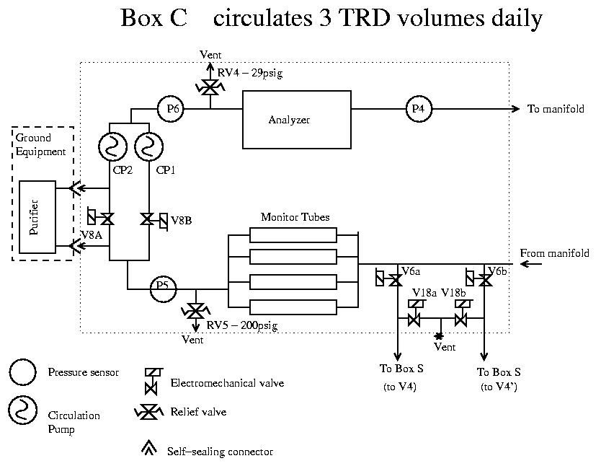
Fig. 2.3 Layout of circulation Box-C

The design includes also straw tubes to monitor gas gain by measuring the pulse height with a Fe⁵⁵ source. The gas analyzer will monitor the gas composition.
In case of necessity to reduce pressure in Box-C and in the TRD (e.g. for refreshing the gas) the valves V6a and V18a (or V6b and V18b) are used.

Box-C operations

Ground State
1) Remove oxygen and water from gas. 2) Remove Xe from storage tank in Box-S on ground if need arises. 3) Test for the gas composition with CO₂ gas analyzer.

Before Launch:
System should be filled and circulating through the purifier well before launch. Circulation should continue until as close to launch time as possible, at which point the pumps are turned off.

After launch at start up
Isolate all segments. Check for losses in each segment. Open all working segments Start CP1. Begin normal operation.

Operation for the return
Stop the two pumps CP1 and CP2.
Close all segment valves.

Normal operation
Run one pump at half-maximum speed. The pump speed can be varied from half to the maximum speed or stopped. Gas circulates through the straws, no purification.
Replace gas lost in normal operation every 24 hours. Check for loss anywhere in straw tubes by looking for pressure change when manifold closed.
Gas composition test. Test for the gas with gas analyzer.
Monitor gas gain measuring tubes pulse-height by USCM ADC.

Failure Recovery
If one of the pumps, CPn or valve V8x doesn’t work, swap to the other branch.

Emergency Operation
- Pressure is above operating value (P4 or P5 or P6 > 29 psig). Relief valve RV4 opens mechanically.
- Pressure p (P4 or P5 or P6) >> 30 psig. V6x and V18x open. without the intervention the USCM
- Pressure is above 200 psig, relief valve RV5 opens mechanically. Close all Manifold valves and stop pump without the USCM intervention.
- Pressure (P4 or P5 or P6) drops (p < 15 psig) below operating value (p_{op} =17.4 psig). Close all Manifold valves, stop pump, close V8a V8b. The UGBC board without the intervention of the USCM will provide this control and will flag through a dedicated signal the HV system. This signal can be disabled or overwritten by the USCM.
- Pressure p (P4 or P6) drops about 3% (this value should be programmable) below the previous measured value. USCM will close all manifold valves, stop pump, close V8a V8b , flag the HV system.

Control System Design

Requirements
- Power supply for one pump continuously on at half speed (12 Volts) during normal operation.
- Pressure gauges signals to be fed to a threshold circuit. If pressure (P4+P5+P6) is below threshold, emergency command to close 2 pair of all manifold valves must be issued without the intervention of the USCM.
- If pressure is too high, (P4 or P5 or P6) >> 30 psig, V6x andV18x can be opened to leave the gas out. This has to be maskable by the USCM
Note that this event could happens simultaneously with the emergency opening of V5 in BOX-S. This implies that up to 3 Marotta MV100 valves could be opened at the same time
- Mechanical status test (open/close) of the valves V18a, V18b, V6a, V6b. Each valve generates a status flag signal that indicates if the valve is open or not.
- Electrical status test of V18a, V18b, V6a, V6b valves. The energized status of the Marotta valve is verified.

Redundancy
- Hot and cold Box-C control board (UGBC) and cables are necessary.

Manifold

From Box-C stainless steel gas lines run to the top rim of TRD and to input and output manifolds.
The 5248 tubes of the TRD are grouped into 41 segments composed of two towers of four 16-tube packages. The packages are connected in series to the manifolds to form 41 separate gas circuits, which can be isolated from the rest of the system by isolation valves on the input and output, as shown in Fig.5. The valves are doubled for redundancy. There are two (for redundancy) pressure sensors for each of the segments.

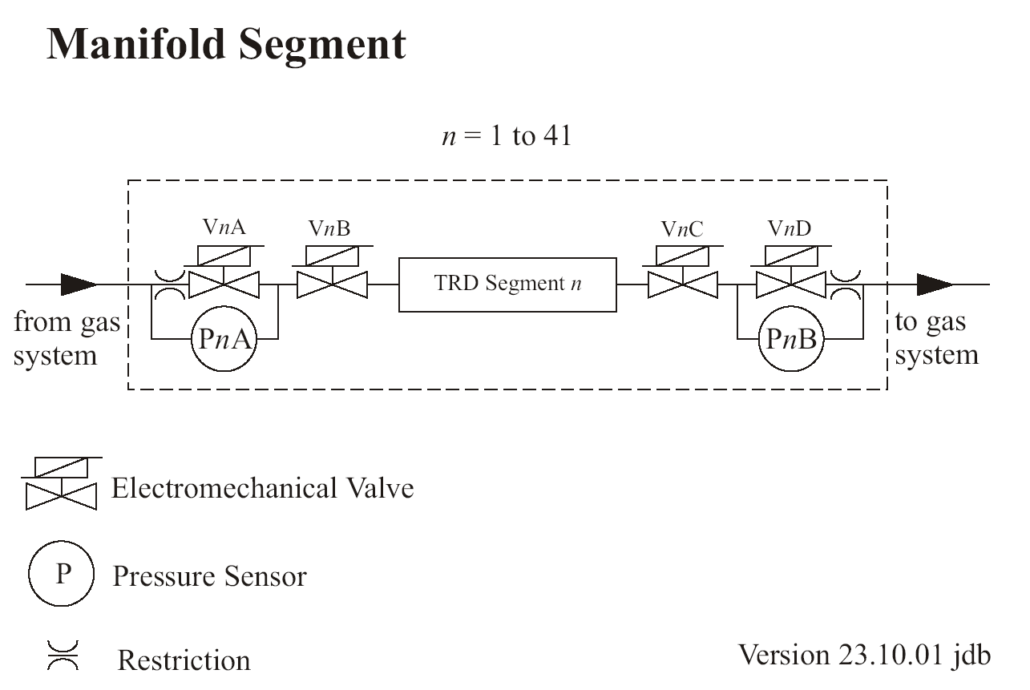

Fig.2.4. One of 41 gas circuits, with isolation valves and pressure sensors

There is a pressure drop of ≅ 46mbar across the restrictions at the nominal flow rate of 1 liter/hour. This equalizes the gas flow rates among the 41 segments, and the pressure sensors PnA and/or PnB to test the flow and detect large leaks can measure it.
The isolation valves work in two modes. In case of a sudden pressure drop, valves are closed automatically to prevent further gas loss. As a periodic test the valves may be closed and the pressure monitored to detect a slow leak. The flipper valves (VnA, VnB, VnC, VnD) require a 100ms 12V 1.5W, pulse to open or close. Commands on flipper valves (open or close) are issued always in pair (A&C, B&D). At the flipper valves have the possibility to hold 3 bar in either direction. They can be flipped from open to close and vice versa by a ±12 V, 100ms pulse, and otherwise consume no power. The valves are positioned at the sides of the TRD in a region where the field is of the order of 100 - 200 Gauss. The pressure sensors (PnA, PnB) operate at 10V, 25mW (or12V, 36mW).

Manifold Operation

Before launch
Before power off for launch, all segment valves should be closed.

Normal Operation
During normal operations the valves VnA VnB VnC VnD are open. Leak checking.

Failure Recovery
In case of a detected leak in tube segment n, close VnA VnB VnC VnD.
Group of elements VnA PnA VnB is equivalent to VnC PnB VnD.

Emergency operation
In case of a large pressure drop, detected by a threshold comparator via P4, P5, P6 in Box-C, the electronics will close all segments valves, valves V8A and V8B in Box-C, stop the pump. The UGBC board without the intervention of the USCM will provide this control and will flag through a dedicated signal the HV sytstem located in the U crate. This signal can be disabled or overwritten by the USCM.

Control System Design

Requirements
Close or open isolation valves in the manifolds.
Sensor signal conditioning for USCM.

Redundancy
UGPS modules containing the control electronics of pressure sensor and UGFV will not be duplicated. In case of electronics failure of one of UGFV board, control is lost of one valve type (A, B, C or D) of all TRD segments.
Hot and cold control board UGMUX and cables are necessary.

Electromechanical components. Specifications
BOX-S
# | Item | n. | Power | Output | Input | Timing | Freq. | Red. | Maker
1 | Valves MV100 | 13 | 24W; @24V | switch on/off | 18-30V | 100 ms | 5/d | yes | Marotta
2 | Pressure/Temperature Sensor 7900 | 4 | 1.1W @ 24 V | 0-5V, 0.1% |  | < 4 ms | continuos | yes | GP:50
3 | Temperature Sensors DS1820 | 4 |  |  |  |  | 1/30 m |  | Dallas

BOX-C
# | Item | n. | Power | Output | Input | Timing | Freq. | Red. | Maker
1 | Valves MV100 | 4 | 24W; @24V 1A | switch on/off | 18-30V |  | 1/d | yes | Marotta
2 | Pressure/Temperature Sensor 7900 | 3 | 5 VDC | 0-5V, 0.1% |  | < 4 ms | continuos | yes | GP:50
3 | Flipper valves 6123 | 2 | 1.5W@12V 125mA | na | open: +12V  close: -12V | <100ms | 1/d | yes | Burkert
4 | Diaphragm pump, UNMP30KNDC | 2 | 2.5 W @ 24V  1.25 W @12V |  | 0-12-24V | CC | continuos  half speed | yes | KNF-Neuenmberg
5 | Gas analyzer mod 2115 | 1 | 4.8W, @12V | RS-232 |  |  | Off when  not in use | no | Square One Technology
6 | MCA 8000A | 1 | 300W @9V, AC adpter (115 V) | RS-232, 4.8-115.6 kb/s | 0-+5 V or 0-+10 V | 250 ns peak time | Off when not in use | no | Amptek
7 | Monitor tubes (+1 µCi Fe⁵⁵ source) | 4 | 120 V

MANIFOLDS
# | Item | n. | Power | Output | Input | Timing | Freq. | Red. | Maker
1 | Pressure Sensors 26PC-C | 82 | 25 mW @10 V | 0-0.1 V |  | 1 ms | 1/5 min | yes | Honeywell
2 | Flipper valves 6123 | 164 | 1.5W, @12V 125mA |  |  | <100 ms | 1/d | yes | Burkert

Note: Burkert could be closed all at once within few seconds

TRD Gas Slow Control System (UGSC)

As outlined before, the Gas Slow Control System is composed by the following elements:
UG Crate, housing DC-DC converters, Crate Back-Plane (UGCB) and the following modules: USCM, UGBS, UGBC, UGMUX, UGFV, UGPS modules. These modules are located close the manifolds, on top of the valves and pressure sensors.
Redundancy is implemented by duplicating all boards except UGPS modules since the manifold itself is redundant.
Each board type will be described from §4.1 to §4.6

TRD Gas Control System Crate (UG Crate)

Most of the TRD electronics will be organized to be hosted in a single crate capable to host 6U height boards (VME connector’s type). The standard AMS crate will be used.
The standard crate has a board to board pitch of 20.32 mm. The standard board will have two 3x 32 VME connectors (0.1” pitch). The allowable height for components on component side is 11.4 mm and on solder side is 5 mm. It has a board thickness of 1.6mm and a front panel width of 20 mm, with a clearance of two times 1mm on each side.
The whole system uses 13 boards (see fig. 4.1) one slot wide each described in the following.
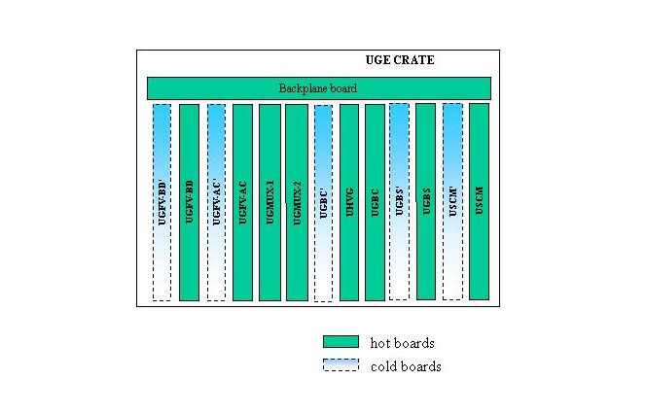

Fig .4.1: TRD Gas Slow Control Crate layout

USCM: These are two boards control all TRD gas system control. One of two is spare. The system core is the USCM (Universal Slow Control Module) used to control all the other boards presents in the crate.
The USCM bus signals will be distributed through the backplane to all the other boards in the crate so that they could be accessed through a memory mapped I/O mechanism.
All the boards will be based on the same Bus I/O interface implemented in an ACTEL A54SX32A FPGA. The possibility to have hot and cold FPGA on some boards will be evaluated.
Two replica of the USCM, the hot and the cold (dashed box in figure refers to cold boards), are used for redundancy.

UGBS: The UGBS board main feature is to control the switch on and off of the Marotta valves present in the Box-S (see Fig. 2.2) when requested by the USCM. Also monitoring of the mechanical status (open/close) and of the electrical activation of the valves is implemented in this board.
One hot and one cold UGBS board and cables are used to implement system redundancy.

UGBC: The UGBC implements all the controls and monitoring necessary for the Box-C subsystem and in particular:

- 2 x Circulation Pump activation and monitor
- 4 Marotta Valves activation and monitor
- 2 Flipper Valve activation
- 4 Monitor Gas Tubes control signal
- Manifolds reset signal control
- 3 GP50 DIM Output Signal Interface

One hot and one cold UGBC board are used to implement system redundancy.

UHVG: The UHVG board generates the high voltage power supply necessary for the BOX-C monitor tubes.

UGM boards: These boards are of two types:

UGMUX: The UGMUX board is used to multiplex the 82 manifold pressure sensor signals coming from the UGM modules (located closer to the manifold, see par. 14) to the USCM ADC (6 ADC input signals are used).
Two identical hot UGMUX boards using different USCM ADC input signals are used to enhance the system reliability.

UGFV: The UGFV boards are used to control the activation of the manifold flipper valves (164 in total). Each board will control 41 valves pairs (for each segment valves A and C, or B and D are activated or deactivated with the same command) so that 4 identical boards (2 hot and 2 cold) are used (UGFV-AC, UGFV-BD).

In total the TRD Gas system crate will host 13 boards.

DC-DC converters: provide necessary voltage and current to operate valves, pumps and other parts of the TRD system and the command electronics from the PDB 28V power.

Table 4.1- Power Supply requirements

Operating Voltage | Normal Power  (W) | Peak Power  (W) | Nominal Current  (A) | Peak Current  (A)
120.0 | <0.05 | - | <0.0004 | -
> 24.0 | 6 | 80 | 0,25 | 3.3
12 | 4.9 | 18 | 0.41 | 1.5
5 | 7.1 | 9 | 1.42 | 1.8
3.3 | 1 | 2 | 0.3 | 0.6
Total | 19 | 109

Table 4.2- DC-DC converters for UG Crate

VDC | Make | Type
120.0 | CAEN | S9025
24.0 | ?VICOR? | ?MIJ00?
11.6 | CAEN | S9022
5.6 | CAEN | S9024
3.3? | CAEN | S9023

Universal Slow Control Module (USCM)

List of commands

Commands to Box-S —> operator controlled
- Open vessel Xe to fill mixing vessel D
- Open vessel CO₂ to fill mixing vessel D
- Open valves V4/V6 to fill Box-C
- Open valve V5 to adjust pressure in mixing vessel D
- Power heaters
- Pressure and temperature measurements
- High rate scan cycle of pressure and temperature measurement
- Low rate scan cycle of pressure and temperature measurement

Commands to Box-C —> operator controlled
- Start gas circulation, open valve V8A, power on pump CP2
- Increase pump speed
- Pressure and temperature measurements

Commands to Manifold —> operator controlled
- Leak test in segment n
- Close segment n
- Test valves VnA VnB VnC VnD

Emergency commands —> no operator intervention
- Open valve V5 for overpressure in vessel D (>290 psi)
- Open valve V6+V18 for over pressure in Box-C (>30 psi)
- Close all Burkert valves for low pressure in Box-C (<15 psi)
- Reset all Emergency Commands

NB: each command has an alternative command (BXCna) for failure recovery.

Box-S Control Board (UGBS)

The main request of this board is to control the valves present in Box-S (V1a, V’1a, V1b, V’1b, V2a, V3a, V2b, V3b, V20a, V20b, V4a, V’4a, V5) with the following functions

- open the valves (normally closed otherwise) for a programmable period ranging from 50 to 15000 ms
- test the mechanical status of the valves
- test the energizing status of the valves

This control is handled from a dedicated ACTEL A54SX32A FPGA interfacing the USCM I/O. The FPGA pilots also the two switches used to control each valve (26 in total). For each valve one switch is used to connect the valve to the 24 VDC power supply line while the other it is used to open the valve for the programmed time (if connected to the 24 VDC). FPGA also manages all the flags to keep track of the status of each valve.
The mechanical status is derived from the corresponding flag binary signal produced by the valves while the energizing status is derived from the measurement of the current in the valve control circuit in the board.
No direct command from USCM is given to valves. The USCM will operates on valves through I/O write and read operations at the UGBS addresses, according to the following tables (add. Values TBD):
Table 4.2 USCM Write/Read operations @ UGBS
USCM Write Operation @ UGBS board write address
DATA[15:0] | Function
0x1XXX | Set enable register to XXX
0x2XXX | Set open time register to XXX
0xC001 | Open V1a
0xC002 | Open V’1a
0xC004 | Open V1b
0xC008 | Open V’1b
0xC010 | Open V2a
0xC020 | Open V2b
0xC040 | Open V3a
0xC080 | Open V3b
0xC100 | Open V4
0xC200 | Open V’4
0xC400 | Open V5
0xC800 | Open V20a
0xD000 | Open V20b
0xE000 | Open V20b and V20a
USCM Read Operation @ UGBS board
ADD[7:0] | Function
Address-1 | Read valve mechanical current status register
Address-2 | Read valve mechanical event register
Address-3 | Read valve energizing current status register
Address-4 | Read valve energizing event register
Address-5 | Read valve enable register
Address-6 | Read valve open time register

The enable 13 bits register (all registers are located in the FPGA) is used to control the connection of each valve to the 24 VDC power supply. The following correspondence between bit and valves is adopted:

Table 4.3 - Valve-bit assignment

bit | 12 | 11 | 10 | 9 | 8 | 7 | 6 | 5 | 4 | 3 | 2 | 1 | 0
Valve | V20b | V20a | V5 | V’4 | V4 | V3b | V2b | V’1b | V1b | V3a | V2a | V’1a | V1a

Writing a “1” will enable the connection (close of the corresponding switch).
The UGBS board will not execute a USCM open command performed on a valve whose corresponding enable bit is set to 0.

The open time 12 bits register is used to program the desired duration of the open valve operations (one register will be used for all the valves).
The LSB corresponds to 10 ms so that 4095*10 ms is the maximum open time possible for each single open command.
The UGBS board will no execute a USCM open valve command performed with such register set to zero.
Any open valve command performed by the USCM will reset the open time register to zero.
The register content is accessible in reading to verify the content before giving the open command.

The mechanical status of the valves is accessible in two different ways by USCM:

- current status register that will allows the USCM to have information of the status of all the valves at the moment of the reading. The correspondence between bits and valves is the same as in the enable register (a 1 signaling that the correspondence valve was in the open state at the moment).

- event register will report, for all the valves, if an open event is happened in the past. For this a 13 bits registers is used to store the transition of the valves to the open state.

The register reading operation by the USCM will reset it to zero.
The correspondence between bits and valves is the same as in the enable register (a 1 signaling that the correspondence valve was in the open state at least one time).

Comparing these two registers a monitor of command flow and the working condition is possible.
Same considerations are also valid for the energizing valve status register.
In this case the status information is derived by measuring if a current > 3 ampere is flowing in the valve control circuit. Also in this case two 13 bits registers, operated as described above, are used.
Both readings will provide the information in a binary format (1=open, 0=close).

If pressure sensor P3a or P3b measure a value above p_{threshold}= 290 psi, a hardwired command will be generated to open valve V5, without intervention of USCM. Nevertheless the command signal generated by P3a or by P3b can be disabled by USCM, if the corresponding sensor is not operating correctly.

Box-C control board (UGBC)

In the following are summarized the device to be controlled by the UGBC board with the relative control functions:

- n.4 Marotta MV100 solenoid valves (V6a, V6b, V18a, V18b)
    - open the valves (normally closed otherwise) for a programmable period ranging from 10 to 30000 ms
    - test the mechanical status of the valves
    - test the energizing status of the valves
- n.2 Burkert 6613 flipper valves (V8A, V8B)
    - open the valves
    - close the valves
- n.2 KNM pumps (CP1, CP2)
    - turn on/off the pumps
    - change pump speed
    - test the energizing status of the pumps
- n.3 GP50-7900 pressure sensor
    - manifold valves reset signal production (close all)
- n.4 monitor straw tubes
    - signal shaping and multiplexing towards the MCA.

This control is handled from a dedicated ACTEL A54SX32A FPGA interfacing the USCM I/O.
The FPGA acts on the MV100 valves and on pumps using the same control scheme described in the previous paragraph (4.3). Pumps are also controlled to be power supplied with two different voltages (24 and 12 Volts) to change pumps speed. For flipper valves control see (4.6).
No direct command from USCM is given to valves. The USCM will operates on valves through I/O write and read operations at the UGBC addresses, according to the following tables (add. Values TBD)
Table 4.4 - USCM W/R operations @ UGBC

USCM Write Operation @ UGBC board write address
DATA[15:0] | Function
0x1XXX | Set enable register to XXX
0x2XXX | Set open time register to XXX
0x300X | Set “speed” register to X
0x400X | Set MCA register to X
0xE001 | Open V6a
0xE002 | Open V6b
0xE004 | Open V18a
0xE008 | Open V18b
0xE010 | Open V6a and V18a
0xE020 | Open V6b and V18b
0xE040 | Open V8A
0xE020 | Close V8A
0xE080 | Open V8B
0xE100 | Close V8B
0xE200 | Activate HV safety signal

USCM Read Operation @ UGBC board
ADD[7:0] | Function
Address-1 | Read v&p current status register
Address-2 | Read v&p event register
Address-3 | Read v&p enable register
Address-4 | Read MV100 valves open time register
Address-5 | Read speed register

The enable 6 bits register (all registers are located in the FPGA) is used to control the connection of each valve and pump to the power supply. The following correspondence between bits and devices is adopted:

Table 4.5 Enable register bits assignment

bit | 5 | 4 | 3 | 2 | 1 | 0
Valve | CP1 | CP2 | V18b | V18a | V6b | V6a

The UGBC board will not execute a USCM open command performed on a valve whose corresponding enable bit is set to 0.

The open time 12 bits register is used to program the desired duration of the open valve (MV100 only) operations (one register will be used for all the valves).
The LSB corresponds to 10 ms so that 4095*10 ms is the maximum open time possible for each single open command.
The UGBC board will no execute a USCM open valve command performed with such register set to zero.
Any open valve command performed by the USCM will reset the open time register to zero.
The register content is accessible in reading to verify the content before giving the open command

The speed 2 bits register is used to set the power supply voltage of the pumps with the following correspondence between bits and devices (bit set to 0 means 24 Volts and 1 means 12 Volts):

Table 4.6 - Speed register bit assignment

bit | 1 | 0
Valve | CP2 | CP1

The speed register content is accessible in reading.

The MCA 2 bits register is used to set which of the 4 signals coming from the straw tubes is to be connected to the input of the MCA.
The MCA register content is accessible in reading.

Same considerations about the event and current status register described in § 4.3 are valid here; the following table summarizes the correspondence between bits and devices:

Table 4.7 Current Status and Event registers Valve-bit assignment

bit | 11 | 10 | 9 | 8 | 7 | 6 | 5 | 4 | 3 | 2 | 1 | 0
Valve | CP2S | CP1S | CP2E | CP1E | V18bE | V18aE | V6bE | V6aE | V18bM | V18aM | V6bM | V6aM

Bit 7 to 0 flag for each valve the value of the mechanical (M) and energized (E) status.
Bits 9 and 8 flag the energizing status of the pumps.
Bits 11 and 10 flag the speed (applied voltage) of the pump.

If pressure sensor P4 or P5 or P6 measure a value above 200 psi or below 15 psi a dedicated signal, to be used in the UGFV boards to start the closure of all the manifolds segments, is activated.

TRD GAS Control System Manifold (UGM)

This electronics, as mentioned in the introduction, controls the flipper valves (FV in the following) and monitor the pressure sensors (PS in the following) of manifold TRD electronics.
PS output signals are handled in two sections: the UGM modules and UGMUX board.
UGM modules are designed to adapt the signals to USCM ADC input while the UGMUX boards are used to multiplex them to the USCM ADC input lines.
FV control commands (Close and Open) coming from the USCM are decoded in the UGFV boards where are generated the necessary valve control signals.
In the following paragraph we discuss the pressure sensor readout (UGPS modules and UGMUX board) and then the flipper valve control board (UGFV).

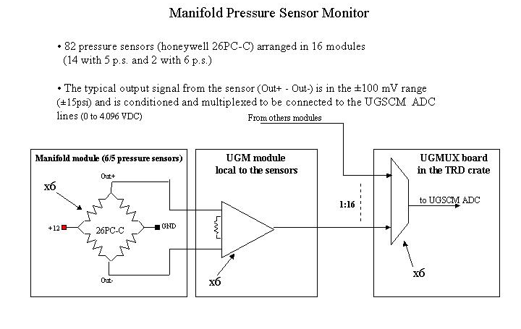

Fig. 4.2: Schematic to of UGPS modules (board local to manifolds)

Control System Manifold (UGPS) modules:

In this paragraph we describe the first part of readout electronic for the pressure sensor. The duty of this module is to transform the bipolar signal coming out from pressure sensors to a unipolar suitable as USCM ADC input (signal conditioning).
This electronic sit as close as possible to pressure sensors and will use the same modularity used in the mechanical assembly of the sensors.
At the moment in 14 manifold module are mechanically assembled together 5 PS and 10 FV while in other 2 module 6 PS and 12 FV.
Each UGPS module will provide signals conditioning for the pressure sensors that are assembled together.
In such way the readout electronic of pressure sensors belonging to different segments, (i.e. P5A, P7A, P8A, P38A, P40A for module 1) are grouped in the same UGPS module, with same modularity of sensors.
In such way the 82 sensors are grouped in 16 modules namely 2 boards with 6 pressure sensors and 14 with only 5.

The pressure sensor (Honeywell 26PC-C) measures the difference of the pressure between the two sides of the sensor as DC voltage difference around -100mV to +100 mV before conditioning, 0-5V after conditioning.
The typical span, the voltage corresponding to the maximum pressure measured, is 100mV (97 Min, 103 Max) for the pressure of 15 psi.
The sensor signal should be transformed to a single ended signal in the range 0 to 4.096V VDC, resolution ±1mV, suitable as USCM ADC line input.
Then the 82 signals have to be multiplexed in the ADC input (6 of the 32 lines are used).
This schematic is represented in Fig. 4.2. The output signals of pressure sensors, indicated as Out + and Out – in Fig. 4.2, are amplified and transformed in a single ended signal in the UGPS module and then are multiplexed to 6 different USCM ADC lines.

The functioning of UGPS module board has been simulated with the circuit represented in Fig.4.3.
The behavior of the sensors is simulated using two sinusoidal voltage generators, same amplitude but opposite phase, and the blue arrows represent the 26PC-C Honeywell voltage output while the red arrow is the single ended amplified output of the circuit, ready to be multiplexed, in the UGMUX board. The pressure sensors are energized 1 time every 5 minutes.

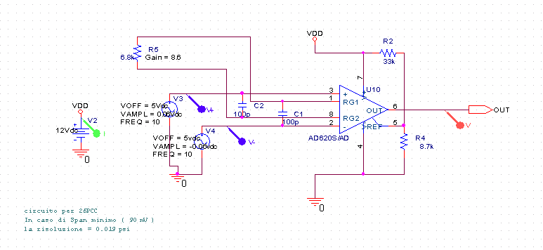
Fig.4.3: Simulation of UGPS module board

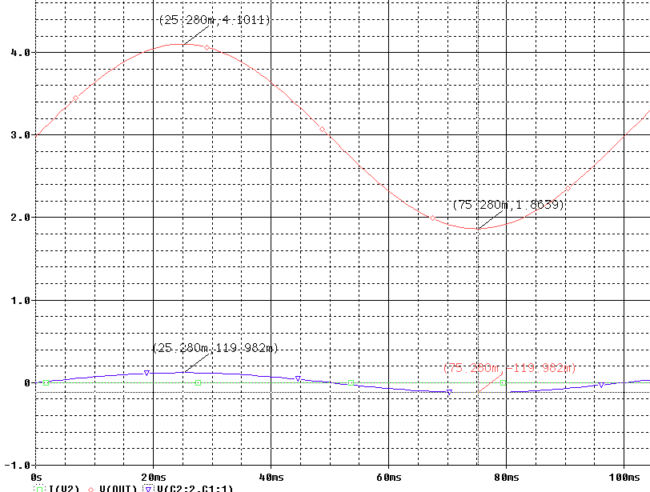
Fig 4.4: Behavior of UGPS module. Blue line represents the input signal, from the 26PC-C pressure sensor. Red line represents the output signal. Vertical axis reports the VDC (in Volt) and the horizontal axis the time (in ns). The curves represent the circuit response to the change of input signal in the case of maximum sensitivity (0 to ±120 mV input variation)

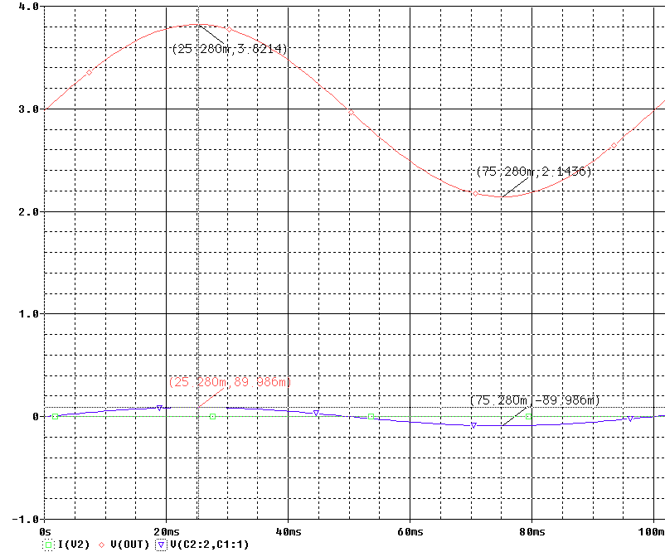

Fig 4.5: Behavior of UGPS module. Blue line represents the input signal from the 26PC-C pressure sensor. Red line shows the output signal. VDC (in Volt) is plotted in the vertical axis and time (in ns) in the horizontal axis. The curves represent the circuit response to the change of input signal in the case of minimum sensitivity (0 to ± 90 mV input variation).

Fig 4.4 and Fig 4.5 show the circuit response to the maximum and minimum 26PC-C pressure sensor sensitivity.
From Fig 4.4 we see that even in the case in which the sensor has a span (120 mV at 15 psi) higher than the typical one (100 mV at 15 psi) (highest sensitivity), the circuit keeps its linearity and the output is in the range of USCM ADC (0 - 4.096).
In the Fig 4.5 it is possible to observe the case of lowest sensitivity, when the response of sensor at difference of pressure of 15 psi is 90 mV. From this it is possible derive the circuit resolution: p = ±15 psi, V_{out} ^{max} = 3821 mV, V_{out} ^{min} = 2143 mV, Res ^{ADC} = 1mV.
Resolution is (P_{max}-P_{min})/ ((V_{out} ^{max} - V_{out} ^{min})×Res ^{ADC}) = 30/(3821-2143) = 0.018 psi ≅ 1.2 mbar. During normal functioning of the gas system, with flows of 1 liter/hour, the pressure drop across one of these sensors will be ≅ 46 mbar, about 40 times the lowest sensitivity. The alarm level could be set to twice this value, or 92mbar (on the input side – 0 mbar on the output side). The setting corresponds to an additional flow of 1 liter/hour on the input and a reduction of 1 liter/hour on the output flow, or a leak of 2 liter/hour. If we close valves VnA and VnC, this would cause a pressure drop of 5 mbar/min in one of the 7-liter segments. A manual leak test of duration around a minute would detect it. The shutdown procedure (controlled the USCM) will be activated when the output voltage of a PS sensor is out of the 2.5 to 3.5 range.

Fig. 4.6: Output signal of differential pressure at sensor PnA, located on the input side of a TRD gas segment n. Output voltages are shown for the following conditions: a) vacuum in Box-C (normal pressure in segment n, VnA and VnC closed); b) no gas flow (VnA open); c) normal flow (with all valves open); d) 2 liter/hour leak in the segment n (with all valves open); e) vacuum in the segment (normal pressure in the rest of the gas system, VnA and VnC closed)

Fig. 4.7: Output signal of the pressure sensor PnB, located on the output side of a TRD gas segment n. Output voltages are shown for the following conditions: a) vacuum in Box-C (normal pressure in segment n, VnB and VnD closed); b) no gas flow (VnD open); c) normal flow (with all valves open); d) 2 liter/hour leak in the segment (with all valves open); e) vacuum in segment n (normal pressure in the rest of the gas system, VnB and VnD in the segment closed).

The UGPS module will allocate the connectors for the FV control signals and for the corresponding transient voltage suppression filters (see next paragraph).

Control System Manifold Boards: Multiplexing Board (UGMUX)

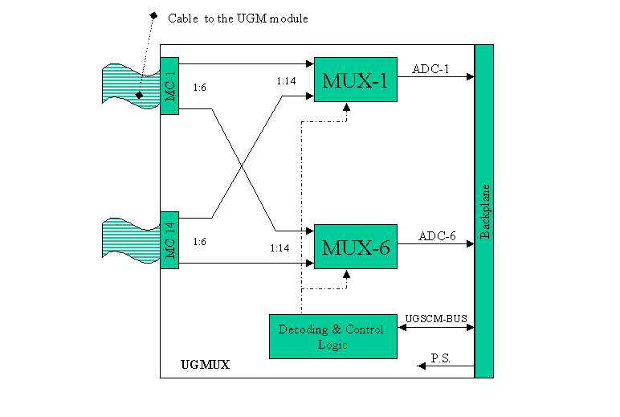
Fig.4.8 From UGPS modules the pressure sensors signals (grouped in 6) are multiplexed to the
ADC input of USCM

The function of UGMUX board, located in the TRD crate, is to multiplex the 82 conditioned PS signals coming from the 16 UGM modules to the ADC input port of USCM. Fig 4.8 shows a functional block diagram of the UGMUX board. MC blocks represent the 16 connectors receiving the signal coming through cable (maximum expected length is 6 meters) from all the modules. Multiplexing is implemented using 6 (16 to 1) analog multiplexers controlled by a single address word and 6 different USCM ADC input line. In such way, using appropriate signals routing, it is possible to connect with a single USCM write command the 6 signals coming from a module. For example, each of 6 inputs of MC-1 corresponding to P5A, P7A, P8A, P38A, P40A, are sent to a different multiplexer and the 5 data are sent to 5 different ADC converter input lines of USCM.
A possible PS monitor routine for module 1 will be:

CONNECT module1
READ P5A
READ P7A
READ P8A
READ P38A
READ P40A

To be accessed by the USMC board, the UGMUX is memory mapped on the USCM I/O bus identified by a single address.
The USCM specifies which module connects to the ADC inputs making a write operation at the UGMUX address in which the data written is used in the UGMUX to decode which module to connect. Table 4.8 shows the correspondence between the data value and the pressure sensor connected.

Table 4.8 - Correspondence between pressure sensors and ADC input gates of USCM.

USCM Write Operation @ UGMUX board address
DATA | ADC-1 | ADC-2 | ADC-3 | ADC-4 | ADC-5 | ADC-6
0x0 | PS-5A | PS-7A | PS-8A | PS-38A | PS-40A | N.U.
0x1 | PS-5B | PS-7B | PS-8B | PS-38B | PS-40B | N.U.
0x2 | PS-10A | PS-16A | PS-18A | PS-25A | PS-25A | N.U.
0x3 | PS-10B | PS-16B | PS-18B | PS-25B | PS-25B | N.U.
0x4 | PS-12A | PS-14A | PS-20A | PS-22A | PS-29A | N.U.
0x5 | PS-12B | PS-14B | PS-20B | PS-22B | PS-29B | N.U.
0x6 | PS-6A | PS-31A | PS-37A | PS-39A | PS-41A | N.U.
0x7 | PS-6B | PS-31B | PS-37B | PS-39B | PS-41B | N.U.
0x8 | PS-1A | PS-3A | PS-9A | PS-24A | PS-34A | PS-36A
0x9 | PS-1B | PS-3B | PS-9B | PS-24B | PS-34B | PS-36B.
0xA | PS-11A | PS-17A | PS-19A | PS-26A | PS-28A | N.U.
0xB | PS-11B | PS-17B | PS-19B | PS-26B | PS-28B | N.U.
0xC | PS-13A | PS-15A | PS-21A | PS-23A | PS-30A | N.U.
0xD | PS-13B | PS-15B | PS-21B | PS-23B | PS-30B | N.U.
0xE | PS-2A | PS-4A | PS-32A | PS-33A | PS-35A | N.U.
0xF | PS-2B | PS-4B | PS-32B | PS-33B | PS-35B | N.U.

The previous monitor routine will become

WRITE (UGMUX-address, 0x0)
READ (ADC-1)
READ (ADC-2)
READ (ADC-3)
READ (ADC-4)
READ (ADC-5)

The implementation of a separated readout chain for each PS (UGMUX-1 and UGMUX-2 boards in UG crate figure) will assure an x2 system redundancy.

Control System Manifold Boards: Flipper Valves Control Board (UGFV)

This board is the main control of flipper valve status. An ACTEL A54SX32A FPGA is used to interface the USCM I/O bus and to drive the switches used to control each flipper valve.
The 41x4 valves of manifolds are commanded from 4 boards, each controlling the 41 flipper valves located in the same position.
So, with reference to UG Crate figure and Fig. 5, UGFV-A board will control the 41 PnA flipper valves, the UGFV-B board will control the 41 PnB valves and so on.
On each board the valves are grouped in 7 groups of 5 and 1 group of 6, each corresponding to the flipper valves hosted in the same manifold module.
USCM will open or close the valve through an appropriate write command as specified in the following table.

Table 4.9 - Correspondence between pressure sensors and ADC input gates of USCM

USCM Write Operation @ UGFV board address
DATA[15:12] | Operation | DATA[11:0]
0x0 | Open on Module 1 | The 12 LSBs bits are one to one associated to the 12 valves of each module and are used to specifies (1=Yes, 0=No) if on the corresponding valves should be applied the Open or Close operation  (i.e. Data[15:0].= 0x2200  will be decoded as  Open Valve-10 of Module-2)
0x1 | Close on Module 1
0x2 | Open on Module 2
0x3 | Close on Module 2
0x4 | Open on Module 3
0x5 | Close on Module 3
0x6 | Open on Module 4
0x7 | Close on Module 4
0x8 | Open on Module 5
0x9 | Close on Module 5
0xA | Open on Module 6
0xB | Close on Module 6
0xC | Open on Module 7
0xD | Close on Module 7
0xE | Open on Module 8
0xF | Close on Module 8

The possibility to open (or close) all the valve through a single USCM command is supported also using a dedicated address value TBD.

A “Valve Reset” signal, routed to the backplane, is also provided so that an emergency closure of the manifolds could be done from the UGBC board (or any other external device) independently from the USCM. (§ 4.4)

The AMS-02 Status Report; 2001
The AMS-02 TRD Gas System
USCM Universal Slow Control Module for AMS 02; III Physikalisches Institut RWTH Aachen
In this case and in all acronyms starting with UG, U stands for Ubergangstrahlung
1 psi = 6.895 10³ pascal = 0.068947 bar; 1 atm = 1013 hPa = 1.013 bar
For more details : http://ams.cern.ch/AMS/Electronics/mech

